When Green Meets Digital: The Surprising Relationships Between Eco-Investments and Crypto Assets in Turbulent Times

Abstract
This paper investigates the interconnectedness and risk transmission mechanisms among green financial instruments—including green bonds, green equities, green sukuk, clean energy assets, and green cryptocurrencies—through the lens of higher-order moments: volatility, skewness, and kurtosis. By applying a novel integration of the Generalized Jaynes-Rosenbaum-Skewness-Kurtosis (GJRSK) model with a Time-Varying Parameter VAR (TVP-VAR) and Wavelet Local Multiple Correlation (WLMC) analysis, the study makes several key contributions to the literature. First, it expands the scope of prior work by including a broader range of green asset classes, notably Islamic green finance and eco-focused digital assets, offering a more holistic view of the green finance ecosystem. Second, the research highlights the structural primacy of volatility spillovers but also emphasizes the overlooked role of skewness and kurtosis in capturing asymmetric and tail risks—particularly in crisis periods. Third, the paper identifies dynamic, time- and scale-dependent determinants of spillovers, including oil and equity market volatility, economic policy uncertainty, and climate risk. These findings advance the literature by deepening our understanding of green market systemic risk and offering practical insights for portfolio diversification, regulatory policy, and sustainable investment strategy design.

Keywords: green equity; green energy; green sukuk; green cryptocurrencies; uncertainty factors

1.0 Introduction
The international financial market is currently undergoing significant changes, with sustainability emerging as a pillar of contemporary investment. In 2023, green bonds were issued at a rate of $575 billion (WEFORM, 2024), and sustainable fund assets reached a level of $30.3 trillion (GSIA, 2024). Climate finance has become a significant trend that is transforming capital markets. However, swift expansion has exceeded our comprehension of how these markets behave during times of crisis. As an example, clean energy investments reached a threshold of $728 billion (BloombergNEF, 2025), and Islamic green finance totalled $3.69 trillion (CPI & UNDP, 2022). However, there are vital questions that have not been answered: How do the shocks spread between traditional green assets and their corresponding Islamic counterparts? What are the underlying connections between green cryptocurrencies and equity shares in renewable energy enterprises? However, the most important question is how skewness and kurtosis risks propagate across these markets in the case of such an event, such as the COVID-19 pandemic or geopolitical conflicts? There are gaps in knowledge levels, which leave investors and policymakers in the dark, making the green economy a $7.2 trillion environment susceptible to systemic risks that it did not expect.
Assets of different classes also appeal to different kinds of investors, who are subject to varying regulations and risk perceptions, and this generates complex pathways through which disturbances or swings in market sentiment may be transmitted. Theoretically and empirically, green markets are highly integrated, and there is a risk spillover between green markets and other financial assets, as well as within green markets themselves (Zhang et al., 2023). Further, geopolitics, climate regulation, energy market shocks, and revision of ESG ratings are associated with these green finance markets and separate factors (Ahmed et al., 2024; Babic, 2024; Bajra et al., 2025; Roy, 2023; Wang et al., 2023; Wang et al., 2025). Such aspects may produce asymmetrical non-linear shocks that even the mean and volatility discussions may not reveal. For example, a change in policies may lead to changes in tail risks or the asymmetry of returns, which may not only influence returns but also many other aspects. Additionally, crypto market shocks may be triggered by climate tech bubbles, which can generate asymmetry and extreme events.
The debate on ethical and green finance has therefore evolved into a study of the dynamic interplay among the various green financial instruments, extending beyond the classical connections to volatility. The interrelationships between green stocks, green bonds, green energy, green sukuk, and green cryptocurrencies suggest that impact is being incorporated into the paradigm shift in which investors evaluate not just the risk-return profile but also a green portfolio in terms of its broader effects. In this light, skewness and kurtosis are higher-order moments (i.e., the third and fourth moments) that reflect asymmetric risks and tail events, which are core elements of the characteristics of return distributions (Jondeau & Rockinger, 2003; Soltyk & Chan, 2023; Kumari et al., 2025). Moreover, skewness and kurtosis are essential to investors and their decision-making processes. Since such occasions involve the asset-pricing mechanism, investors demand a premium to absorb the incremental risk caused by the skewness of the returns. As such, they would tend to incline more towards assets that exhibit positive skewness and low kurtosis (Jurczenko & Maillet, 2006). Such instances help market players reduce asymmetric or fat-tail risks associated with extreme downside (or upside) events, which is beneficial in strengthening risk management strategies in sustainable investments (Mensi et al., 2024; Wang et al., 2025). The effect is that investors are investigating both the spill-ups of higher-order moments in green bonds, green equities, green energy, green sukuk, and green cryptocurrencies. According to Bouri (2023), kurtosis spillovers imply that extreme events and hazards of fat-tailed distributions are transmitted to each other, and skewness spillovers imply the transmission of asymmetric risks through symptoms across markets. The importance of higher-order moments to the successful pricing of assets, optimal hedging and asset allocation has been stressed by numerous scholars (e.g., Amaya et al., 2015; Hadhri & Ftiti, 2019). Therefore, this paper attempts to cover interconnectivity and risk spillovers in a broader sense, encompassing volatility, particularly their response to various uncertainties, including policy, environmental, and economic uncertainties.
Past research has analyzed the connection and the spillover impacts between different sustainable and green investments and has used dissimilar empirical methods to seize the extent to which returns and volatility transmit inside and between clean energy markets (Chatziantoniou et al., 2022; Lu et al., 2023; Soltani et al., 2025), climate change equity markets, ESG equities (Umar et al., 2020; Chen & Lin, 2022; Wu & Qin, 2024; J) There is also the exploration of dynamic interaction in this literature, asymmetric spillovers, and extreme connectedness which are significant contributions to portfolios dynamic.
A diverse set of advanced techniques, such as wavelet coherence and quantile VAR (Cui & Maghyereh, 2023), Diebold-Yilmaz spillover indices (Mensi et al., 2024), and options-implied frameworks (Bouri et al., 2023), are applied in literature that has been considered to examine the higher-order moment connectedness across markets. Cui and Maghyereh (2023) disclose that returns are the most dominant drivers of short-term connectedness in global oil markets. In contrast, volatility, skewness, and kurtosis spillovers are likely to be long-term ones. It is worth noting that their previous work (Cui & Maghyereh, 2022), which applied a time-frequency Rényi transfer entropy method to cryptocurrencies, emphasized that volatility comovements are not only more profound than skewness or kurtosis, but the COVID-19 pandemic also played a significant role in these interactions.
Mensi et al. (2024) apply this knowledge to stock and commodity markets, reporting that jump and realized volatility spillovers are significantly higher than those of skewness and kurtosis, especially during crisis events such as the COVID-19 pandemic and the Ukraine-Russia war. Bouri et al. (2023) observe this behaviour in the precious metals and energy markets, where system-wide connectedness becomes less pronounced in higher-order moments as well as in lower frequencies. In a complementary manner, Cui and Maghyereh (2023) demonstrate that the risks associated with portfolios in international oil and commodity futures are moment-dependent and time-varying, focusing on the divergent dynamics of higher moments in the context of trade wars and the occurrence of geopolitical shocks.
Zhou et al. (2023) and Gao et al. (2024, 2025) provide further research to conclude that climate and geopolitical risks have a substantial time-variation and asymmetry impact on carbon, energy, rare earth, and clean energy markets, as well as their market spillover effects. Moreover, the volatility and jump components contribute significantly to cryptocurrencies over skewness- and kurtosis-based dynamic network analysis (Hanif et al., 2023) or LASSO-VAR (Hasan et al., 2025). In addition to that, additional studies (e.g., Zhang et al., 2023; Hao & Pham, 2024; Nekhili & Bouri, 2023; Bouri et al., 2021; Zheng et al., 2024; Bouri, 2023; Wang et al., 2025) uniformly indicate that incorporating higher-order moments into spillover and risk management models can reveal information on market dynamics that is of vital importance in environments of financial upthrust and crisis.
The paper integrates the Generalized Jaynes-Rosenbaum-Skewness-Kurtosis (GJRSK) and the Time-Varying Parameter VAR (TPV-VAR) models to examine the relationship among clean energy, green stocks, green bonds, Islamic green stocks, green sukuk, and green cryptocurrencies on a time-series and multiple orders of proportion basis. Additionally, other papers have discussed the possibility of risk being associated with dissimilar moments (such as CV-CS, CV-CK, and CS-CK) in addition to just the same moments (such as Conditional Variance, Conditional Skewness, and Conditional Kurtosis) (Ahmed et al., 2024; Nekhili & Bouri, 2023). This will give rise to a cross-moment spillover analysis of cross-financial green assets as well.
Moreover, the current literature shows that the transmission mechanism of the spillover has been altered due to COVID-19 and the Russia-Ukraine war. We therefore examine the changes in spillover transmission channels and their functions (Billiah et al., 2024; Cui & Maghyereh, 2022; Hoque et al., 2024, 2025; Mensi et al., 2024). In addition, various research studies reveal that both economic, financial, and climatic uncertainty play a significant role in making the spillover process between financial assets significant and moderate (Gao et al., 2024, 2025; Zhou et al., 2023). Therefore, we will consider the consequences of these uncertainties on spillover dynamics.
The present paper makes several important contributions to the literature on ethical and green finance, as the utilization of sophisticated methodologies has enabled an understanding of the contemporary interdependencies between various green financial products. To begin with, the study offers significant improvements (when compared to Zhang et al., 2023, and Wang et al., 2025), thereby making a considerable contribution to the literature on the phenomenon of connectedness in green financial markets. Although Zhang et al. (2023) explore green bonds, the clean energy index, wind, solar index, and sustainability index, and primarily base their research on the investigation of lower- and higher-order moments in the given markets, the current research extends this investigation to include more asset classes. Moreover, Wang et al. (2025) focus on the green bond and equity markets in China. This study is specifically interested in green equities, green bonds, Islamic green equities, green sukuk, and green cryptocurrencies, thereby representing a broader scope of ethical finance instruments.
Moreover, we combine the GJRSK model with a time-varying parameter VAR (T P V-VAR) model in a time-frequency domain. The method used also encompasses traditional return and volatility spillovers, as well as examines the higher-order moment behaviour, including skewness and kurtosis, to gain a more comprehensive understanding of the dynamics of risk transmission across these markets. Lastly, this study provides innovative insights into the role that shocks in one domain at a given moment may have on another, which has been poorly covered in the literature.
The next parts of this paper organized as following. The following section describes and the empirical method. The next section elaborates the empirical results. The final section concluding study highlight the practical implications and future research.

2.0 Data and methodology
2.1 Dataset Description
We take various types of green assets to determine the volatility, skewness, and kurtosis risk spillover effects among green markets. The performance of green bonds in the European, Chinese, and American markets can be assessed using the MSCI Bloomberg Barclays Euro Green Bond Index (GB EU), the FTSE Green Bond Index (Onshore CNY) (GB CH), and the MSCI Bloomberg Barclays US Green Bond Index (GB US) as proxies. The Bloomberg Barclays MSCI Green Bond Index (GB GL) is utilized as a proxy for the worldwide green bond market.
The performance of conventional green equity markets in the American, Chinese, European markets, and global can be assessed using MSCI China Broad ESG Leaders (CHESG), MSCI USA Broad ESG Leaders (USAESG), MSCI Euro Broad ESG Leaders (EUROESG), and MSCI World ESG Leaders (WESG). Similarly, the performance of Islamic green equity markets can be assessed using the S&P 500 ESG Shariah Index (SP500I) and the S&P Global 1200 ESG Shariah Index (SPGSI). We take the S&P Global Clean Energy Index (SPENG) to proxy the clean energy.
Green cryptocurrencies, proxied by Ripple (XRP), Stellar (XLM), Cardano (ADA), Nano (XNO), and IOTA (MIOTA), represent the top 5 with the highest capitalization. These are cryptocurrencies worth investigating due to their distinctive traits, market position, technological advancements, and environmental consciousness. Ripple and Stellar focus on fast cross-border payments, Cardano emphasizes scientific studies, Nano promises instant and fee-free transactions, and IOTA is geared towards the Internet of Things (Pham et al., 2022). They have attracted attention and have practical applications. Studying these cryptocurrencies will provide insight into the application of innovative technologies and the potential for disrupting the world of finance and other fields. Moreover, the research would address the growing need to pursue environmental sustainability and its significance in the evolving financial landscape and cryptocurrency market.
The Green Sukuk Index (GSI) was created using three popular index strategies: Market Capitalization Weighted Index, Price Weighted Index, and Equally Weighted Index. To measure the performance of individual green sukuk and their market capitalization, we adopted the market capitalization index methodology (S&P 500), which allows for a greater number of green sukuk issuances. A few of the requirements under which corporate green sukuk should satisfy to qualify for an index entail:
a. The sukuk should have a maturity of more than one year.
b. Sukuk must be recorded in Thomson Reuters as a green bond or ESG bond.
c. The sukuk should be rated by one of the most popular rating agencies of the country (Malaysia) or region; and
d. The Sukuk also have to satisfy the requirements of Islamic finance accountability, such as the requirement to adhere to the Accounting and Auditing Organization of Islamic Financial Institutions (AAOIFI) requirements.
The index is (in US dollars) to mitigate any impacts from currency risk while preserving uniformity. It includes 174 green sukuk issuances issued by 18 private corporates in Malaysia, Indonesia, UAE, Saudi Arabia, and Bahrain. Notably, the green sukuk proceeds are mostly allocated towards energy efficiency projects, as demonstrated in Table 1. To examine and interpret data accurately, we rely on continuously compounded daily returns. This method involves calculating the variance in the logarithmic percentage between two consecutive prices. By doing so, we can gain a deeper understanding of the changes and trends within the data set (Arouri et al., 2011) of the 17 assets in our dataset, expressed as: $r_{i,t}=ln\left({P_{i,t}}/{P_{i,t−1}}\right)×100$.
DataStream and Bloomberg were used to obtain our data. We are analysing observations performed daily between May 2020 and September 2024. Our reason is that we needed to concentrate on the data on green sukuk, which was finally revealed during this period. We took the beginning of 2020, when many green sukuk were issued, and the end of September 2024 to gather as much data as possible. In May 2023, the United Nations declared the COVID-19 pandemic over. In our research, nevertheless, it was difficult to distinguish the influence of the pandemic on other phenomena. For example, the Russian invasion, which began on February 24, 2022, has had numerous adverse financial effects that were not directly linked to COVID-19. One of the resources of energy being produced in large quantities by Russia is crude oil, natural gas, and coal. The sanctions imposed on Russia resulted in a reduction of crude oil supply, causing uncertainty in the global energy and financial markets (Umar et al., 2022). To better assess the situation, we divided our study period into two: between May 3, 2020, and February 23, 2022, we refer to the period of the COVID-19 pandemic, and the time after that we will call the period of the Russian invasion. In this manner, we will be able to observe the implications of the two events.
2.2 Higher-order moment risk measure
The financial time series is not consistent with a normal distribution, but it portrays the elucidation of leptokurtosis, a fat-tailed distribution, and a leverage effect. The aim of evaluating the conditional volatility, skewness, and kurtosis of green bonds, equities, energy sukuk, and cryptocurrencies is achieved through the implementation of the GJRSK model, introduced by Nakagawa and Uchiyama (2020), which is a GARCHSK model with leverage effects added to generate a high-order moment model. The GJRSK model exists within the framework of GJR, which allows for describing asymmetric responses to positive and negative shocks. Such an ability facilitates the study of the time series of green bonds, equities, energy sukuk, and cryptocurrencies, which exhibit an asymmetric nature (Jiang et al., 2018; Huang et al., 2020). The formula of the GJRSK model could be as follows:
$\{\begin{aligned}r_{t}=a_{1}r_{t−1}+{\text{ε}}_{t} \\ h_{t}=β_{0}+β_{1}{\text{ε}}_{t−1}^{2}+β_{2}h_{t−1}+β_{3}{\text{ε}}_{t−1}^{2}I_{\{η_{t−1}<0\}} \\ s_{t}=γ_{0}+γ_{1}η_{t−1}^{3}+γ_{2}s_{t−1}+γ_{3}η_{t−1}^{3}I_{\{η_{t−1}<0\}} \\ k_{t}=δ_{0}+δ_{1}η_{t−1}^{4}+δ_{2}k_{t−1}+δ_{3}η_{t−1}^{4}I_{\{η_{t−1}<0\}} \\ η_{t}=h_{t}^{{−1}/2}{\text{ε}}_{t}\end{aligned}$ (1)
When $η_{t}∨I_{t−1}∼g\left(0,1,s_{t},k_{t}\right)$, where I_{t−1} is the information set at $t−1$. The formulation $g\left(0,1,st,kt\right)$ is a density probability with a mean of $0$, a variance of 1, a skewness of s_{t}, and a kurtosis of k_{t}. The parameters of the GJRSK model are determined by maximising the log likelihood. The variable r_{t} represents the returns of the green bond, equities, energy sukuk, and cryptocurrencies as a vector and is calculated as $100×{\left(Pt−Pt−1\right)}/Pt−1$, where $Pt$ is the closing market index obtained daily.
2.3 TVP-VAR connectedness
We continuously use, in the initial phase of our empirical study, an up-to-date connectedness technique based on Generalised F or Variance or Variance Decomposition (GVD), which is founded on a Time-Varying Parameter Generalised Autoregressive (TGPVAR) model (Antonakakis et al., 2018). This technique addresses the shortcomings of rolling windows. There is the TVP-VAR (1) identified by the Bayesian Information Criterion (BIC) that is given as:
$Y_{t}=β_{t}Y_{t−1}+ε_{t}{;ε}_{t}∨F_{t−1}∼N\left(0,S_{t}\right)$ (2)
$\vec{\left(β_{t}\right)}=\vec{\left(β_{t−1}\right)}+ν_{t};ν_{t}∨F_{t−1}∼N\left(0,Ξ_{t}\right)$ (3)
where $Y_{t}$ and $Y_{t−1}$ represent $N×1$ dimensional vectors of endogenous variables; $ε_{t}$ is the disturbance term with dimensions $N×1$ that has a time-varying variance-covariance matrix, $S_{t}$, which is $N×N$ dimensional; $β_{t}$ is a VAR coefficient matrix with dimensions $N×N$; $ν_{t}$ is a disturbance vector with dimensions N^2×1 that features a time-varying variance-covariance matrix, Ξ_t, which is $N^{2}×N^{2}$ in size; $\vec{\left(β_{t}\right)}$ denotes the vectorized form of $β_{t}$.
In order to obtain GFEVD, we transform the TVP-VAR into a Vector Moving Average (VMA) form:
$Y_{t}=\sum_{j=0}^{∞}{A_{jt}ε_{t−j}}$ (4)
where $A_{jt}$ is an $N×N$-dimensional matrix as claimed in the standard Wold Representation Theorem, the unscaled GFEVD is scaled to form the scaled GFEVD denoted as $θ_{ij,t}^{g}\left(H\right)$ such that the sum of every row is one. $θ_{ij,t}^{g}\left(H\right)$ is subsequently indicated by the extent to which the $j$ variable influences the $i$ variable in terms of its proportion of forecast errors variance, which is termed the directional connectedness of the $i$ variable with the $j$ variable. This measure is estimated by
$θ_{ij,t}^{g}\left(H\right)=\frac{S_{ii,t}^{−1}\sum_{t=1}^{H−1}{{\left(e_{i}^{'}A_{t}S_{t}e_{j}\right)}^{2}}}{\sum_{j=1}^{k}{\sum_{t=1}^{H−1}{\left(e_{i}A_{t}S_{t}A_{t}^{'}e_{i}\right)}}}$ (5)
In order to be certain that every row adds up to one so that the selected variables explain all of the variable i forecast error variance, we calculate the scaled GFEVD (${\tilde{θ}}_{ij,t}^{g}\left(H\right)$ as:
${\tilde{θ}}_{ij,t}^{g}\left(H\right)=\frac{θ_{ij,t}^{g}\left(H\right)}{\sum_{j=1}^{N}{θ_{ij,t}^{g}\left(H\right)}}$ (6)
where, $\sum_{j=1}^{k}{θ_{ij,t}^{g}\left(H\right)=1,}\sum_{i,j=1}^{k}{{\tilde{θ}}_{ij,t}^{g}\left(H\right)=k,}$ and $e_{i}$ is a vector that has a value of one at the $i^{th}$ position and zero elsewhere; ${\tilde{θ}}_{ij,t}^{g}\left(H\right)$ denotes a metric of bidirectional connectedness from index $j$ to index $i$ at horizon $H$.

The GFEVD is applied to determine various measures of connectedness within the context provided by Diebold and Yilmaz (2014) - including the overall system-connectedness across the considered indexes under analysis ($T{CI}_{t}$) as expressed in Eq. (7), the cumulative directional connectedness of index $i$ to all other indexes ($C_{j←i,t}\left(H\right)$) in Eq. (8), the complete directional connectedness of all other indexes to index $i$($C_{i←j,t}\left(H\right)$) in Eq. (9), and the net total directional connectedness ($C_{i,t}$)) as shown in Eq. (10).
$T{CI}_{t}=\frac{\sum_{\begin{aligned}i,j=1 \\ i≠j\end{aligned}}^{N}{{\tilde{θ}}_{ij,t}^{g}}\left(H\right)}{\sum_{i,j=1}^{N}{{\tilde{θ}}_{ij,t}^{g}\left(H\right)}}$ (7)
$C_{j←i,t}\left(H\right)=\frac{\sum_{\begin{aligned}j=1 \\ j≠i\end{aligned}}^{N}{{\tilde{θ}}_{ji,t}^{g}}\left(H\right)}{\sum_{i,j=1}^{N}{{\tilde{θ}}_{ji,t}^{g}\left(H\right)}}×100$ (8)
$C_{i←j,t}\left(H\right)=\frac{\sum_{\begin{aligned}j=1 \\ i≠j\end{aligned}}^{N}{{\tilde{θ}}_{ij,t}^{g}}\left(H\right)}{\sum_{i,j=1}^{N}{{\tilde{θ}}_{ij,t}^{g}\left(H\right)}}×100$ (9)
${C_{i,t}\left(H\right)=C}_{j←i,t}\left(H\right)−C_{i←j,t}\left(H\right)$ (10)
2.4 Wavelet local multiple correlation
The notion of wavelet local multiple correlation is primarily based on the hypothesis of multiple regression. The authors in this study applied the wavelet local multiple regression framework presented by Fernandez-Macho (2018) and Mann et al. (2009). As an illustration, $R$ is a multivariate feature of a time series, which has a dimension n, whose measurement is at time $t=1,2…..T$. Based on Fernandez-Macho (2018) and Polanco-Martinez et al. (2020), when the researcher sets r ∈ R, they can use a local regression in $s∈\left[1….T\right]$ to minimize the weighted sum of the square errors:
$W_{w}=\sum_{t}{∂\left(t−w\right){\left[E_{w}\left(R_{−i,t}\right)−r_{}\right]}^{2}}$ (11)
In Equation (15) 1(r) denotes a specific moving average functional which is based on the time-series data set of $R_{t}$,$R_{s}$ and $E_{w}\left(R_{−i,t}\right)$, which is a local functional representation of $\{R\{r{}_{i}\}$. The local measures of determination that accompany it can be explained as follows:
$Z_{r}^{2}=1−\frac{Z_{w}RR_{r}}{TWR,R_{r}},r=1,2.3…….T$ (12)
In Equation (15), the residual and overall weighted sum of squares are represented by $Z_{w}RR_{r}$, $TWR,R_{r}$, respectively.
Wavelet local multiple correlation follows multivariate regression in the estimation process. Under correlation estimation set $U_{kt}=$, as the wavelet coefficients of level $k$ $\left(k=1…,k\right)$. In this regard, $k$ represents the highest degree of wavelet transform decomposition achieved by the utilization of the multiple discrete wavelets transform (MDVT) with $r∈R,wherei=1….,n$.
Based on recent discoveries of Polanco-Martinez et al. (2020) at each wavelet level k, the wavelet local multiple correlation $∂R\left(∂k\right)$ can be calculated as the root of the regression coefficient of determination of a linear combination of variables:
$\hat{∂}W_{r}\left(θ_{k}\right)=\sqrt{Z_{r}^{2},}k=1,…kr=1,….T$ (13)
Conversely, the $Z^{2}$ coefficients in the multiple local regression of a variable $q_{i}$ on other variables in the system represent the squared correlation between the fitted values and the actual values derived from the multiple local regression of $q_{i}$. As noted by Fernández-Macho (2018) and Polanco-Martínez et al. (2020), the consistent estimator of wavelet local multiple correlation is implemented.
$\hat{∂}W_{r}\left(θ_{k}\right)={corr\left(∂\left(t−r\right)\right)}^{\frac{1}{2}}W_{ik,}\sqrt{Z_{r}^{2},}$ (14)
${\left(∂\left(t−r\right)\right)}^{\frac{1}{2}}W_{ik}$
In Equation (14), $W_{ik}$ is chosen to ensure that the local regression of other regressors maximizes the corresponding coefficient of determination, with $W_{ik}$ showcasing the corresponding vector of fitted values.
The wavemucor software calculates the WLMC, incorporating six frequently used weighted functions for averaging and smoothing. These six weighted functions consist of the uniform window, the Bartlett triangular window, Cleveland's tricube window, Wendland's truncated power window, the Gaussian window, and the Epanechnikov's window. However, Polanco-Martínez et al. (2020) pointed out that Cleveland's tricube and Epanechnikov's parabolic kernels may not provide significant utility due to negative values in their associated spectral functions. Additionally, Fernández-Macho (2018) suggested using Bartlett’s triangular, Wendland’s truncated power, and Gaussian windows as they are more appropriate for signal extraction and smoothing, yielding non-negative values. By default, the wavemulator program selects the Gaussian window, as it is most similar to uniform weights in the time domain within a specific bandwidth, among various other advantages.
3.0 Results and discussion
Table 1 presents data on Green Sukuk issuances across various countries, detailing the use of proceeds and the number of issuances per entity. The Green Sukuk market is dominated by Malaysia, with multiple issuers financing energy efficiency and renewable energy projects. Notable issuers include Quantum Solar Park (27 issuances), Cypark Ref (19), and Sinar Kamiri (14), reflecting strong government and private sector participation. Indonesia is a key sovereign issuer, with 24 Green Sukuk focused on energy efficiency. Corporate entities like Majid Al Futtaim (5 issuances) and Etihad Airways (3 issuances) are actively involved in the UAE. At the same time, Saudi Arabia has emerging players like Saudi Electricity Co. (5), Riyad Bank (4), and Saudi National Bank (6). Bahrain’s Infracorp (3 issuances) also contributes to regional sustainability efforts. Across all issuers, energy efficiency is the dominant use of proceeds, followed by renewable energy and green construction. The data highlights the increasing role of financial institutions and corporations in Islamic sustainable finance, particularly in Southeast Asia and the Middle East, positioning Green Sukuk as a vital tool for funding environmentally responsible projects.
Table 2 provides the descriptive statistics of the green markets for the second-order moments (Volatility-Panel A), third-order moments (Skewness – Panel B), and fourth-order moments (Kurtosis – Panel C) respectively. We observe the following: firstly, the fourth-order moments exhibit highest mean returns for all the green markets compared to the second-order, and third-order moments. Secondly, among the green markets, we find that the Green Sukuk index exhibit highest mean return in absolute terms across all the higher order moments compared to other green assets. Third, the second-order (Panel A), and fourth-order (Panel C) tables shows that green markets have positive skewness and high excess kurtosis, whereas, third-order moments (Panel B) exhibit both positive and negative skewness for different assets but have high excess kurtosis for all green assets similar to other panels. Finally, we observe that all the green markets timeseries have non-normal distribution based on Jarque-Bera (JB) test, have no unit root as per ERS statistics, and no autocorrelation in the given series and also squared series as per Ljung-Box Q(10), and Q(20) statistic results.
3.2 Static spillover effects
Tables 3, 4, and 5 present the system-wide Total Connectedness Index (TCI) of the green markets for volatility (CV), skewness (SK), and kurtosis (KU), respectively. The analysis reveals notable variation in the Total Connectedness Index (TCI) across volatility (Table 3), skewness (Table 4), and kurtosis (Table 5). Among these, volatility spillovers emerge as the most dominant, as reflected by the TCI of 69.80 in Table 3. In contrast, the TCI for skewness (Table 4) is 45.91, and for kurtosis (Table 5) is 51.45, suggesting that tail risk and asymmetry, while significant, are less influential than volatility in driving systemic interactions among green assets. These findings are broadly consistent with those of Ahmed et al. (2024), who found volatility to dominate higher-moment spillovers in carbon and energy markets. However, kurtosis became more prominent during periods of market stress. In our case, volatility maintains its leading role, which may reflect the greater market sensitivity of green markets to daily shocks. In contrast, Bouri (2023) reported relatively more substantial spillovers from skewness in the U.S. market, particularly among green and brown energy stocks. Our results differ slightly in this regard, with skewness playing a secondary role. This divergence may stem from our sample's broader international asset base, which includes Islamic finance (e.g., green sukuk), emerging market green bonds, and green-cryptocurrencies assets that may have different asymmetry dynamics compared to U.S.-based energy sectors. Moreover, our findings resonate with Cui & Maghyereh (2022), who showed higher-order spillovers (especially kurtosis) among cryptocurrencies during COVID-19. Green cryptocurrencies (ADA, MIOTA, XNO) are key contributors to both kurtosis and skewness spillovers, highlighting these assets' speculative and extreme return behavior. However, unlike Cui & Maghyereh’s findings, where kurtosis overtook volatility during crises, our study shows that volatility remains dominant, even during geopolitical uncertainty (i.e., the Russia-Ukraine war period).
The analysis of volatility transmission dynamics in table 3 exhibits that among the green cryptocurrencies, ADA, XNO, and XLM emerge as significant transmitters, propagating volatility to other markets. Conversely, MIOTA and XRM exhibit a receiver role, absorbing volatility spillovers. The green bond indices (GB.US, GB.EU, GB.CH, GB.GL) and green equity indices (WESG, USAESG, EUROESG, CHESG), along with the traditional S&P 500 index, consistently display negative net spillovers, indicating their tendency to be influenced by volatility originating from other assets. Notably, SPGSI and SPENG buck this trend, acting as transmitters. However, the most striking observation is the overwhelming dominance of the GSI as a major volatility propagator, with its substantial positive net spillover dwarfing all other assets.
The analysis of the kurtosis spillover in table 4 highlight that, ADA, XNO, XRM, WESG, USAESG, SPGSI, and GSI emerge as key transmitters, with GSI showing a remarkable net spillover of 57.87%, underscoring its significant influence on risk dynamics. Conversely, MIOTA, XLM, GB.US, GB.EU, GB.CH, GB.GL, EUROESG, CHESG, SP500I, and SPENG are identified as receivers, indicating their susceptibility to shocks from other assets. Moreover, he analysis of the skewness spillover in table 5 shows that MIOTA, XNO, XLM, WESG, SP500I, SPGSI, and GSI are identified as significant volatility transmitters, with GSI notably exhibiting a high net spillover of 63.99%, indicating its strong influence on the volatility dynamics of other assets. Conversely, ADA, XRM, GB.US, GB.EU, GB.CH, GB.GL, USAESG, EUROESG, CHESG, and SPENG are classified as receivers, suggesting they absorb shocks from other sources.
We further explore the cross-moment spillover of green financial markets in Tables 6,7, and 8. We observe that TCI of joint connectedness between CV-KU among green markets is 78.15 (see Table 6) which is higher than joint moment connectedness among KU-SK (70.88), and CV-SK (70.34). The findings support the findings of Ahmed et al., 2024, and Nekhili and Bouri, 2023, that apart from transmissions within identical moments (CV, SK, KU), risk spillovers occur across different higher order moments like CV-KU, KU-SK, and CV-SK.

3.3 Dynamic analysis
Figure 1 displays the dynamic evolution of total connectedness among the conditional higher-order moments volatility (CV), skewness (SK), and kurtosis (KU) for green assets, estimated using a 200-day rolling window. The connectedness index exhibits notable time variation, underscoring dynamic systemic risk in green financial markets. A general downward trend is observed from 2020 to 2023, indicating a decoupling of higher-moment interlinkages and suggesting improved market resilience, which is in line with findings by Zhou et al. (2023), who document a similar reduction in long-term connectedness in metals during periods of macroeconomic recovery. Volatility (CV) remains the dominant contributor to total spillovers, confirming its central role in systemic risk propagation as widely evidenced in prior studies (e.g., Bouri et al., 2021; Umar et al., 2022). In contrast, skewness and kurtosis exhibit weaker yet more erratic connectedness levels, marked by episodic spikes most notably in early 2021 and again in 2024. These peaks likely correspond to external shocks or structural breaks driven by macroeconomic policy shifts or investor sentiment changes, consistent with the contagion patterns observed by Ding et al. (2021) during the COVID-19 pandemic and the Russia–Ukraine conflict. The resurgence in total connectedness in 2024 implies heightened interdependence among these risk dimensions, echoing the findings of Jiang and Chen (2023), who report a reintensification of spillovers during phases of geopolitical instability.
Figure 2 captures the net total spillover indices for volatility across green assets and ESG-related indices, revealing substantial time variation in risk transmission. During 2020–2021, assets such as ADA, MIOTA, XNO, XLM, and XRM emerged as net transmitters of volatility, a pattern consistent with elevated contagion during crisis periods as identified by Bouri et al. (2021) in cryptocurrency markets. This was followed by a period of relative stability in 2022, where diminished spillovers aligned with reduced systemic uncertainty, paralleling the findings of Zhou et al. (2023) for the carbon-energy-metal system. However, spillovers reemerged in 2023–2024, particularly across ESG indices (e.g., GB.US, GB.EU, EUROESG, USAESG, SPENG), highlighting renewed systemic risk and increased cross-market dependencies, in line with results from Umar et al. (2022), who emphasize the rising vulnerability of ESG investments to global economic policy shifts.
Figure 3 illustrates the net skewness spillover dynamics, capturing asymmetric risk propagation. Cryptocurrencies (ADA, MIOTA, XNO, XLM) register high positive skewness spillovers in 2023–2024, indicating disproportionate risk transmission likely tied to speculative trading and regulatory news. This aligns with Ding et al. (2022), who find that skewness spillovers intensify during sudden climate or policy shocks. Traditional indices (SP500I, SPGSI) and ESG benchmarks (EUROESG, USAESG, WESG) also exhibit rising skewness-based spillovers, especially during the early COVID-19 phase, corroborating previous findings on the asymmetry of systemic responses during crises (Bouri et al., 2021). The GSI index again plays a prominent role in early sample periods, highlighting its sensitivity to asymmetric market movements and supporting the growing literature emphasizing skewness as a critical dimension in financial contagion (Zhou et al., 2023; Umar et al., 2022).
Figure 4 presents the net spillover dynamics in terms of kurtosis, emphasizing the behavior of tail-risk transmission. Cryptocurrencies such as XNO, XLM, and XRM exhibit pronounced kurtosis spillovers during 2023–2024, consistent with extreme return clustering and the findings of Yousaf and Ali (2022), who document similar spikes in higher-order moment risks in crypto-asset markets. Traditional indices (SP500I, SPGSI) also show increasing kurtosis spillovers, suggesting that tail risks are not confined to emerging digital assets but extend to conventional markets during turbulent periods. ESG indices such as EUROESG, USAESG, and WESG show elevated kurtosis spillovers in 2020–2021, reflecting the pandemic-related shock transmission previously observed by Jiang and Chen (2023). The GSI index exhibits extreme kurtosis spikes, pointing to exceptional tail-risk events and reinforcing the need to integrate higher-order moments into systemic risk analysis.
Thus, while the results affirm that higher-moment connectedness (kurtosis and skewness) reveals critical asymmetries and tail risks in green finance, particularly through crypto-assets, volatility remains the central mechanism of systemic transmission (Ahmed et al., 2024). This insight extends the literature by validating the structural primacy of volatility in diversified green markets, including Islamic finance components, and contextualizing higher-order risk within broader financial uncertainty. Furthermore, the results confirm the heterogeneous and dynamic nature of higher-order risk spillovers, with strong parallels to prior studies in climate finance and asset interdependence. They further underscore the necessity of incorporating skewness and kurtosis in risk assessment frameworks (Mensi, et al. 2024; Wang et al., 2025).
3.4 Network analysis of subsamples
The network analysis of subsamples reveals critical insights into the interconnectedness among diverse asset classes, especially during periods of market stress. Figure 5 and Figure 6 displays the network connectedness of green assets across higher order moments (a. Volatility, b. Skewness, and c. Kurtosis) during COVID-19, and Russian-Ukraine war periods respectively. The plots highlight the total dynamic connectedness between green markets, where node size reflects each asset’s contribution to system-wide connectedness and color differentiates net transmitters (yellow) from net receivers (blue). During COVID-19 (Figure 5(a)), the GSI index stands out as a significant net receiver, absorbing spillovers from various assets, while cryptocurrencies like XNO, XLM, XRM, MIOTA, and Green Bonds (US, Europe, China, and Global), along with ESG (China) function as key net transmitters, driving market-wide shocks. Traditional financial and ESG indices (e.g., SP500I, SPGSI, ESG (US, Europe, and World)) primarily act as receivers, influenced by external spillovers. It can be observed that the interconnectedness between the green markets become stronger at fourth-order moment (Fig 5(c)) compared to the second-order moment (Fig 5(a)). This finding aligns with Zhou et al. (2023), who demonstrated that higher-order moment spillovers, including volatility, skewness, and kurtosis, exhibit significant variation across different financial markets. Similar to their results, this analysis shows that the interconnectedness of green markets can intensify during crises such as the COVID-19 pandemic. The concentration of spillovers into specific nodes like the GSI index is consistent with previous work, indicating that systemic risk accumulates around critical nodes, acting as 'shock absorbers' during financial turmoil. For example, the higher absorption of spillovers by the GSI index mirrors the role of carbon markets identified by Zhou et al. (2023), which also serve as significant recipients of volatility and skewness spillovers. The skewness-based analysis in Graph 5(b) further illustrates the asymmetric nature of risk transmission, revealing that green assets and Islamic financial instruments play a significant role in driving skewness-related spillovers. This asymmetric impact reflects the findings of Nakagawa and Uchiyama (2018), who noted that extreme shocks often propagate unevenly across financial networks, disproportionately affecting certain asset classes. In this context, the dominant net recipients, such as GSI, illustrate how concentrated risk absorption can exacerbate systemic vulnerabilities.
Figure 6, shows the network connectedness of green markets during Russian-Ukraine war across higher-order moments. During this period, the interconnectedness clearly becomes stronger as we move towards the higher-order moments (i.e. from figure 6(a) to figure 6(c)). Green cryptocurrencies (XNO, MIOTA), USAESG remain to be the net receivers consistently across all of the higher order moments, whereas, US Green Bond (GB.US), Euro ESG, and China ESG (CHESG) remain to be net transmitters across all of the higher order moments. This pattern of interconnectedness, where certain nodes act as dominant transmitters/receivers, aligns with findings by Baruník and Křehlík (2018), who observed that volatility spillovers are often dominated by a few key markets, reinforcing the idea that financial contagion is not uniformly distributed across all assets. Remaining green assets in this study during this period shifted from net receivers to net transmitters across different higher order moments. Similar phenomenon of dynamic characteristic of variable spillover from net recipients to transmitter’s and vice-versa is observed among other asset classes in previous studies like Shaik et al., 2024; Raza Rabbani et al., 2024.
Overall, these findings emphasize the critical importance of network analysis in identifying systemic risks, particularly within interconnected financial systems. The results echo with the findings of previous studies that have shown that the spillovers rise sharply during periods like COVID-19, and Russian-Ukraine war (Alkhazali et al., 2025; Naeem et al., 2023; Shaik et al., 2023; Hoque et al., 2024; Billah et al. 2024; Hoque et al., 2025;). It is important to understand that the dynamic nature of these networks demands continuous monitoring, especially as market structures evolve in response to economic shocks and regulatory changes. This work extends the existing literature by highlighting the role of green markets in shaping the broader financial landscape, reinforcing the need for diversified risk management strategies to mitigate systemic vulnerabilities.
3.5 Determinants of Spillover across Higher-Order Moments in Green Markets
The analysis examines the dynamic relationship that exists between the higher-order moments of the Total Connectedness Index (TCI) of green markets, namely, volatility (CV), skewness (SK), and kurtosis (KU) to other financial uncertainty measures, viz., CLMT, EPU, VIX, OVX, GVZ, EVZ, OFR, EMV. This is achieved by applying Wavelet Local Multiple Correlation (WLMC) to reveal time-varying and dependency structure on scales and conclude that there exist crucial mutations in the way uncertainty spreads over into the interconnectedness and stability of green financial assets.
Based on the WLMC analysis, we observe the following. First, the key predictors of spillover on TCI (CV) constitute OVX (oil market volatility) and GVZ (gold market volatility) in medium-term and EVZ (equity market volatility) and OFR (overall financial risk) in the long-term, which means that the overall financial distress and the traditional market volatilities play an essential role in the interconnectedness and stability in green markets (Wang et al., 2023; Li et al., 2024). Second, the key spillover determinants of TCI (KU) are EPU (economic policy uncertainty) and the conventional market volatility measures (VIX, OVX) in the medium term, implying that an increase in economic policy uncertainty and wider market volatility is linked to the higher probability of extreme interlinkages in green markets (Pham et al., 2022; Pham et al., 2021). Third, among the key factors influencing spillover of TCI (SK) there are CLMT and VIX (traditional market fear index) in the long-term which means that in the long-run green market interconnectedness skewness alterations reflect overall interest and instances of surge of fear in traditional markets (Ren et al., 2023).
Overall, the WLMC analysis shows that green market spillover determinants are time- and situation-dependent. Long-run relationships generally represent significant economic and financial relationships that are crucial to green finance stability, while medium- and short-run relationships are more susceptible to transitory shocks and shifting market conditions (Alomari et al., 2024). The results are significant in reducing risks in and from green markets and creating efficient risk management policies for sustainable portfolios in an interdependent global economy, as excessive volatility in green market relationships is strongly driven by various types of financial uncertainty (Baker et al., 2016; Bloom, 2009). Additionally, the study supports the previous studies that green finance are influenced by factors like geopolitics, energy market shocks, climate policy changes, and ESG ratings (Ahmed et al., 2024; Bajra et al., 2025; Wang et al., 2025). This analysis of the determinants of spillovers across higher order moments in green markets help market participants to reduce asymmetric and tail risks and improve strategies in sustainable investments (Hadhri and Ftiti, 2019; Bouri, 2023; Mensi, et al. 2024).
4. Conclusion
In this paper, we explore the higher-order moment-connectedness between different green markets such as green bonds, green equities (conventional and Islamic), green cryptocurrencies, and Green Sukuk Index (GSI). To achieve this, we used both the static and rolling-window spillover methods, network analysis and wavelet local multiple correlation (WLMC) approach to have a comprehensive idea of how the volatility, skewness, and kurtosis risk spread across such quickly growing green asset classes. The main findings of this paper show that volatility spillovers are the most pronounced type of connectedness within green markets, whereas higher-order moments, especially kurtosis and skewness can provide insight into asymmetric and tail-risk spillovers. The dynamics of these spillovers were also articulated by the rolling-window analysis, which highlighted the times of increased interdependence. The network analysis conducted on crisis periods (COVID-19 and Russia-Ukraine war) provided an observation that the GSI was a major net receiver in the COVID-19 situation, with some net transmitter and receiver trends between some green cryptocurrencies and ESG indices throughout the Russia-Ukraine war. Moreover, the determinants of these spillovers are also identified as time- and scale-specific, with conventional market uncertainty measures (e.g., volatility in oil and gold, economic policy uncertainty, and the VIX) being crucial towards green market connectivity.
Our findings are in line with the previous research on the dominance of volatility in spillover of financial markets (Ahmed et al., 2024; Bouri, 2023). Nevertheless, we saw the stable dominant position of volatility even in the geopolitical uncertainties, as opposed to some other studies (Cui & Maghyereh, 2023) where the results led to dramatic kurtosis during crises. This dispersion could be explained by our larger international asset base, such as the Islamic financing and emerging market green bond that might have time-varying sensitivity to daily shocks. Our results reveal the importance of skewness and kurtosis, particularly by green cryptocurrencies, are consistent with those of Cui & Maghyereh (2023) and Hanif et al., (2023), in that they indicate that such assets are highly speculative and have extreme returns. The observed connectedness during crisis was also observed in existing literature on financial contagion (Alkhazali et al., 2025; Hoque et al., 2024; Shaik et al., 2023). The distinct feature of our study is the inclusion of a broad spectrum of green assets, including the innovation of Green Sukuk Index, into the higher-order moment connectedness framework that offers an extended picture of how risk is transmitted throughout the green finance system.
Our results provide a few opportunities regarding future research. To begin with, the increased use of green cryptocurrencies in transferring higher order risks deserves further research on their peculiar risk profile and exposure to possible hits of contagions into the financial system as a whole. Emerging investigations might be done on the regulatory outcome of these findings, especially on the integration of green cryptocurrencies into mainstream portfolios of the finances. Second, the time-and-scale dependent calculus of spillover determinants implies that there may be a necessity in adaptive strategies to risk management and that the study of green portfolio risk algorithms should examine the possibility of real-time and dynamic hedging strategies. Third, some green assets, especially green cryptocurrencies and green sukuk are in their early stages of development which limits the availability of the historical data. This may affect the rigour of the long run analysis and hence extending the time series patterns and building more refined green market indices might be helpful to future studies.
The implications of our findings are crucial to investors, policymakers, and financial institutions. When it comes to investing in green assets, not only volatility, but skewness, and kurtosis should be taken into consideration, particularly in green cryptocurrencies and Islamic finance tools, which form the basis of diversification strategies. Policymakers are advised to allow the schema of green market to be interdependent and fragile and this requires an early regulatory structure and stress testing, which incorporate higher-order moments. These sophisticated risk considerations should be imbibed in the financial institution models where the sustainable portfolio is resilient. Finally, this paper supports a complex and dynamic risk assessment in an expanding green financial domain.

References
Ahmed, F., Islam, M. M., & Abbas, S. (2024). Assessing the impact of Russian–Ukrainian geopolitical risks on global green finance: a quantile dependency analysis. Environmental Economics and Policy Studies, 1-27.
Ahmed, R., Bouri, E., Hosseini, S., & Hussain Shahzad, S. J. (2024). Spillover in higher‐order moments across carbon and energy markets: A portfolio view. European Financial Management, 30(5), 2556-2595.
Ahmed, R., Bouri, E., Hosseini, S., & Hussain Shahzad, S. J. (2024). Spillover in higher‐order moments across carbon and energy markets: A portfolio view. European Financial Management, 30(5), 2556-2595.
Alharbi, S. S., Naveed, M., Ali, S., & Moussa, F. (2025). Sailing towards sustainability: Connectedness between ESG stocks and green cryptocurrencies. International Review of Economics & Finance, 98, 103848.
AlKhazali, O., Kirimhan, D., Rabbani, M. R., Billah, S. M., & Shaik, M. (2025). Cryptocurrencies and alternative bonds: Novel evidence on co-movement and risk sharing. Global Finance Journal, 101149.
Alomari, M., Selmi, R., Mensi, W., Ko, H. U., & Kang, S. H. (2024). Dynamic spillovers in higher moments and jumps across ETFs and economic and financial uncertainty factors in the context of successive shocks. The Quarterly Review of Economics and Finance, 93, 210-228.
Aloui, C., Mejri, S., Hamida, H. B., & Yildirim, R. (2025). Green bonds and clean energy stocks: Safe havens against global uncertainties? A wavelet quantile-based examination. The North American Journal of Economics and Finance, 76, 102310.
Amaya, D., Christoffersen, P., Jacobs, K., & Vasquez, A. (2015). Does realized skewness predict the cross-section of equity returns?. Journal of Financial Economics, 118(1), 135-167.
Babic, M. (2024). Green finance in the global energy transition: Actors, instruments, and politics. Energy Research & Social Science, 111, 103482.
Bajra, U. Q., Aliu, F., & Prenaj, V. (2025). Connectivity of green financial assets under geopolitical risks and market-implied volatility. Finance Research Letters, 76, 107037.
Baker, S. R., Bloom, N., & Davis, S. J. (2016). Measuring economic policy uncertainty. The quarterly journal of economics, 131(4), 1593-1636.
Bloom, N. (2009). The impact of uncertainty shocks. econometrica, 77(3), 623-685.
BloombergNEF Report, (2025). Global Investment in the Energy Transition Exceeded $2 Trillion for the First Time in 2024, According to BloombergNEF Report. https://about.bnef.com/blog/global-investment-in-the-energy-transition-exceeded-2-trillion-for-the-first-time-in-2024-according-to-bloombergnef-report/
Bouri, E. (2023). Spillovers in the joint system of conditional higher-order moments: US evidence from green energy, brown energy, and technology stocks. Renewable Energy, 210, 507-523.
Bouri, E., Lei, X., Jalkh, N., Xu, Y., & Zhang, H. (2021). Spillovers in higher moments and jumps across US stock and strategic commodity markets. Resources Policy, 72, 102060.
Bouri, E., Lei, X., Xu, Y., & Zhang, H. (2023). Connectedness in implied higher-order moments of precious metals and energy markets. Energy, 263, 125588.
Chatziantoniou, I., Abakah, E. J. A., Gabauer, D., & Tiwari, A. K. (2022). Quantile time–frequency price connectedness between green bond, green equity, sustainable investments and clean energy markets. Journal of Cleaner Production, 361, 132088.
Chen, Y., & Lin, B. (2022). Quantifying the extreme spillovers on worldwide ESG leaders' equity. International Review of Financial Analysis, 84, 102425.
Chen, Y., Jiang, Q., Dai, Z., & Liu, Y. (2025). The impact of climate policy uncertainty on the correlations between green bond and green stock markets. International Review of Financial Analysis, 104046.
Cui, J., & Maghyereh, A. (2022). Time–frequency co-movement and risk connectedness among cryptocurrencies: new evidence from the higher-order moments before and during the COVID-19 pandemic. Financial Innovation, 8(1), 90.
Cui, J., & Maghyereh, A. (2023). Higher-order moment risk connectedness and optimal investment strategies between international oil and commodity futures markets: Insights from the COVID-19 pandemic and Russia-Ukraine conflict. International Review of Financial Analysis, 86, 102520.
Cui, J., & Maghyereh, A. (2023). Time-frequency dependence and connectedness among global oil markets: Fresh evidence from higher-order moment perspective. Journal of Commodity Markets, 30, 100323.
Diebold, F. X., & Yılmaz, K. (2014). On the network topology of variance decompositions: Measuring the connectedness of financial firms. Journal of econometrics, 182(1), 119-134.
Fernández-Macho, J. (2018). Time-localized wavelet multiple regression and correlation. Physica A: Statistical Mechanics and its Applications, 492, 1226-1238.
Gao, W., Jin, X., Zhang, H., & He, M. (2025). The asymmetric response of higher-order moments of precious metals to energy shocks and financial stresses: Evidence from time-frequency connectedness approach. Energy Economics, 142, 108171.
Gao, W., Wei, J., Zhang, H., & Zhang, H. (2024). The higher-order moments connectedness between rare earth and clean energy markets and the role of geopolitical risk: New insights from a TVP-VAR framework. Energy, 305, 132280.
Global Sustainable Investment Alliance (2024). Global sustainable investment review finds US30 trillion invested in sustainable assets. https://www.gsi-alliance.org/global-sustainable-investment-review-finds-us30-trillion-invested-in-sustainable-assets/
Hadhri, S., & Ftiti, Z. (2019). Asset allocation and investment opportunities in emerging stock markets: Evidence from return asymmetry-based analysis. Journal of International Money and Finance, 93, 187-200.
Hanif, W., Ko, H. U., Pham, L., & Kang, S. H. (2023). Dynamic connectedness and network in the high moments of cryptocurrency, stock, and commodity markets. Financial Innovation, 9(1), 84.
Hao, W., & Pham, L. (2024). Dynamic connectedness in the higher moments between clean energy and oil prices. Energy Economics, 140, 107987.
Hasan, M. B., Hossain, M. N., Khatun, H., Uddin, G. S., Bilgin, M. H., & Tian, S. (2025). Using smart transportation assets to hedge fossil energy markets: Evidence from quantile-based VAR approach. PLoS One, 20(5), e0317748.
Hasan, M., Naeem, M. A., Arif, M., & Yarovaya, L. (2021). Higher moment connectedness in cryptocurrency market. Journal of Behavioral and Experimental Finance, 32, 100562.
Hoque, M. E., Billah, M., Kapar, B., & Naeem, M. A. (2024). Quantifying the volatility spillover dynamics between financial stress and US financial sectors: Evidence from QVAR connectedness. International Review of Financial Analysis, 95, 103434.
Hoque, M. E., Tee, L. T., Uddin, M. A., Kew, S. R., & Bilgili, F. (2025). Time-frequency connectedness between climate exchange-traded funds and climate policy uncertainty. Borsa Istanbul Review.
Huang, Z., Liang, F., Wang, T., & Li, C. (2020). Modeling dynamic higher moments of crude oil futures. Finance Research Letters, 39, 101570. https://doi.org/10.1016/j.frl.2020.101570
Jelena, J., & Saša, P. (2025). Investigating volatility spillovers: connectedness between green bonds, conventional bonds, and energy markets. Research in International Business and Finance, 102850.
Jiang, Y., Jiang, C., Nie, H., & Mo, B. (2018). The time-varying linkages between global oil market and China’s commodity sectors: Evidence from DCC-GJR-GARCH analyses. Energy, 166, 577–586. https://doi.org/10.1016/j.energy.2018.10.116
Jlassi, N. B., Lahiani, A., Mefteh-Wali, S., & Mselmi, N. (2025). ESG and sustainable development: Evidence from DCC-GARCH R2 decomposed connectedness measures. Finance Research Letters, 79, 107222.
Jondeau, E., & Rockinger, M. (2003). Conditional volatility, skewness, and kurtosis: existence, persistence, and comovements. Journal of Economic dynamics and Control, 27(10), 1699-1737.
Jurczenko, E., & Maillet, B. (Eds.). (2006). Multi-moment asset allocation and pricing models (Vol. 393). Hoboken, NJ: John Wiley & Sons.
Kumari, P., Shankar, A., Alghafes, R., Broccardo, L., & Walsh, S. T. (2025). Exploring the Interrelationship Between Energy, Geopolitical Risk, and Bitcoin Based Green Business Strategies. Business Strategy and the Environment.
Li, Y., & Du, Q. (2024). Oil price volatility and gold prices volatility asymmetric links with natural resources via financial market fluctuations: Implications for green recovery. Resources Policy, 88, 104279.
LSEG (2024). Investing in the green economy 2024. https://www.lseg.com/content/dam/lseg/en_us/documents/sustainability/investing-in-green-economy.pdf
Mensi, W., Ko, H. U., Sensoy, A., & Kang, S. H. (2024). Higher-order moment connectedness between stock and commodity markets and portfolio management. Resources Policy, 89, 104647.
Mikhaylov, A., Yousif, N. B. A., Dincer, H., Yüksel, S., & Karpyn, Z. (2025). Analysis of the knowledge and innovation-based customer expectations for the green crypto assets in investment strategies using artificial intelligence and facial expression-based fuzzy modelling. Quality & Quantity, 1-30.
Naifar, Nader. "Interactions between renewable energy tokens, oil shocks, and clean energy investments: Do COP26 policies matter?." Energy Policy 198 (2025): 114497.
Nakagawa, K., & Uchiyama, Y. (2020). GO-GJRSK Model with Application to Higher Order Risk-Based Portfolio. Mathematics, 8(11), 1990. https://doi.org/10.3390/math8111990
Nekhili, R., & Bouri, E. (2023). Higher-order moments and co-moments' contribution to spillover analysis and portfolio risk management. Energy Economics, 119, 106596.
Pham, L. (2021). Frequency connectedness and cross-quantile dependence between green bond and green equity markets. Energy Economics, 98, 105257.
Pham, L., & Nguyen, C. P. (2022). How do stock, oil, and economic policy uncertainty influence the green bond market?. Finance Research Letters, 45, 102128.
Pham, L., Karim, S., Naeem, M. A., & Long, C. (2022). A tale of two tails among carbon prices, green and non-green cryptocurrencies. International Review of Financial Analysis, 82, 102139. https://doi.org/10.1016/j.irfa.2022.102139
Polanco-Martínez, J. M., Fernández-Macho, J., & Medina-Elizalde, M. (2020). Dynamic wavelet correlation analysis for multivariate climate time series. Scientific Reports, 10(1), 21277.
Raza Rabbani, M., Hassan, M. K., Jamil, S. A., Sahabuddin, M., & Shaik, M. (2024). Revisiting the impact of geopolitical risk on Sukuk, stocks, oil and gold markets during the crises period: fresh evidence from wavelet-based approach. Managerial Finance, 50(3), 514-533.
Ren, X., Li, J., He, F., & Lucey, B. (2023). Impact of climate policy uncertainty on traditional energy and green markets: Evidence from time-varying granger tests. Renewable and sustainable energy reviews, 173, 113058.
Roy, P. K. (2023). Enriching the green economy through sustainable investments: An ESG-based credit rating model for green financing. Journal of Cleaner Production, 420, 138315.
Shaik, M., Jamil, S. A., Hawaldar, I. T., Sahabuddin, M., Rabbani, M. R., & Atif, M. (2023). Impact of geo-political risk on stocks, oil, and gold returns during GFC, COVID-19, and Russian–Ukraine War. Cogent Economics & Finance, 11(1), 2190213.
Shaik, M., Varghese, G., & Madhavan, V. (2024). The dynamic volatility connectedness of global financial assets during the Ebola & MERS epidemic and the COVID-19 pandemic. Applied Economics, 56(8), 880-900.
Shao, S. F., Li, Y., & Cheng, J. (2023). Clean cryptocurrency and green assets: A quantile connectedness approach. Applied Economics Letters, 1-9.
Soltani, H., & Abbes, M. B. (2025). Does US Financial Instability Matter on Clean, Green, and Sustainable Investment Indices? Evidence from TVP-VAR and Wavelet Coherence Approaches. Asia-Pacific Financial Markets, 1-22.
Soltyk, S. J., & Chan, F. (2023). Modeling time‐varying higher‐order conditional moments: A survey. Journal of Economic Surveys, 37(1), 33-57.
Tiwari, A. K., Kumar, S., & Abakah, E. J. A. (2024). Correlation and price spillover effects among green assets. Annals of Operations Research, 1-26.
Umar, M., Riaz, Y., & Yousaf, I. (2022). Impact of Russian-Ukraine war on clean energy, conventional energy, and metal markets: Evidence from event study approach. Resources Policy, 79, 102966. https://doi.org/10.1016/j.resourpol.2022.102966
Umar, Z., Kenourgios, D., & Papathanasiou, S. (2020). The static and dynamic connectedness of environmental, social, and governance investments: International evidence. Economic Modelling, 93, 112-124.
United Nations. (2023). WHO chief declares end to COVID-19 as a global health emergency. https://news.un.org/en/story/2023/05/1136367
Wang, F., Ma, W., Mirza, N., & Altuntaş, M. (2023). Green financing, financial uncertainty, geopolitical risk, and oil prices volatility. Resources Policy, 83, 103716.
Wang, Y., Cheung, A. W. K., Yan, W. L., & Wang, B. (2025). Connectedness of China’s green bond and green stock markets at the low-and high-order moments: The role of economic and climate policy uncertainty. The North American Journal of Economics and Finance, 78, 102410.
WEFORM (2024). What are green bonds and why is this market growing so fast? https://www.weforum.org/stories/2024/11/what-are-green-bonds-climate-change/
Wu, R., & Qin, Z. (2024). Asymmetric volatility spillovers among new energy, ESG, green bond and carbon markets. Energy, 292, 130504.
Yousfi, M., & Bouzgarrou, H. (2025). Exploring interconnections and risk evaluation of green equities and bonds: fresh perspectives from TVP-VAR model and wavelet-based VaR analysis. China Finance Review International, 15(1), 117-139.
Zhang, W., He, X., & Hamori, S. (2022). Volatility spillover and investment strategies among sustainability-related financial indexes: Evidence from the DCC-GARCH-based dynamic connectedness and DCC-GARCH t-copula approach. International Review of Financial Analysis, 83, 102223.
Zhang, W., He, X., & Hamori, S. (2023). The impact of the COVID-19 pandemic and Russia-Ukraine war on multiscale spillovers in green finance markets: Evidence from lower and higher order moments. International Review of Financial Analysis, 89, 102735.
Zheng, T., Zhang, H., & Ye, S. (2024). Monetary policies on green financial markets: Evidence from a multi-moment connectedness network. Energy Economics, 136, 107739.
Zhou, Y., Wu, S., Liu, Z., & Rognone, L. (2023). The asymmetric effects of climate risk on higher-moment connectedness among carbon, energy and metals markets. Nature Communications, 14(1), 7157.

Table 1: GSI structure
Sukuk Name | Country | Use of Proceeds | Issuances
Cypark Ref Sdn Bhd | Malaysia | Energy efficiency | 19
Edra Solar Sdn Bhd | Malaysia | Energy efficiency | 1
Hsbc Amanah | Malaysia | Sustainable Development Projects | 1
Pasukhas Green Assets Sdn Bhd | Malaysia | Renewable Energy Projects | 7
PNB Merdeka Ventures Sdn Bhd | Malaysia | Green constructions (buildings) | 9
Quantum Solar Park (semananjung) Sdn Bhd | Malaysia | Energy efficiency | 27
Sinar Kamiri Sdn Bhd | Malaysia | Energy efficiency | 14
Tadau Energy Sdn Bhd | Malaysia | Renewable Energy Projects | 12
Telekosang Hydro One Sdn Bhd | Malaysia | Energy efficiency | 15
UiTM Solar Power Sdn Bhd | Malaysia | Energy efficiency | 15
Indonesia Government | Indonesia | Energy Efficiency | 24
Majid Al Futtaim | UAE | Energy Efficiency | 5
Etihad Airways | UAE | Energy Efficiency | 3
DIB Sukuk Ltd | UAE | Energy Efficiency | 4
Saudi Electricity Co. | Saudi Arabia | Energy Efficiency | 5
Riyad Bank | Saudi Arabia | Energy Efficiency | 4
Saudi National Bank | Saudi Arabia | Energy Efficiency | 6
Infracorp | Bahrain | Energy Efficiency | 3
Source: Bloomberg
Notes: This table presents a summary of cumulative green sukuk issuances from 18 corporates in Malaysia, Indonesia, UAE, Saudi Arabia, and Bahrain along with the use of a green sukuk proceeds by the respective corporates.

Table 2 (Panel A - Volatility): Descriptive statistics of green markets
 |  | Mean | Variance | Skewness | Ex.Kurtosis | JB | ERS | Q(10) | Q2(10)
Green bonds
GB US | Bloomberg Barclays MSCI US Green Bond Index | 0.0001 | 0.005 | 6.332*** | 67.060*** | 315734.881*** | -7.093 | 6834.931*** | 2924.113***
GB EU | Bloomberg Barclays MSCI Euro Green Bond Index | 0.0003 | 0.009 | 4.805*** | 35.684*** | 92581.826*** | -7.042 | 8498.725*** | 4784.413***
GB CH | FTSE Chinese (Onshore CNY) Green Bond Index | 0.0001 | 0.007 | 4.122*** | 27.007*** | 54052.386*** | -7.773 | 6574.837*** | 3085.570***
GB GL | Bloomberg Barclays MSCI Green bond index | 0.0001 | 0.008 | 4.529*** | 27.252*** | 55907.386*** | -8.825 | 4210.238*** | 2541.701***
Green Equity
WESG | MSCI World ESG Leaders | 0.0008 | 0.008 | 10.239*** | 122.437*** | 1044681.276*** | -7.391 | 8057.320*** | 4447.641***
USAESG | MSCI USA Broad ESG Leaders | 0.0014 | 0.007 | 9.292*** | 102.286*** | 732677.141*** | -6.305 | 9026.215*** | 4920.919***
EUROESG | MSCI Euro Broad ESG Leaders | 0.0009 | 0.007 | 8.613*** | 88.076*** | 546006.419*** | -7.058 | 9410.903*** | 5397.001***
CHESG | MSCI China Broad ESG Leaders | 0.0024 | 0.008 | 4.052*** | 23.893*** | 43151.878*** | -5.852 | 8078.669*** | 5072.013***
Green Islamic Equity
SP500I | S&P 500 ESG Shariah Index | 0.0015 | 0.007 | 9.074*** | 101.780*** | 724588.431*** | -6.336 | 8797.089*** | 4551.204***
SPGSI | S&P Global 1200 ESG Shariah Index | 0.0012 | 0.008 | 8.730*** | 91.140*** | 583777.528*** | -6.228 | 9306.761*** | 5363.195***
Clean Energy
SPENG | S&P Global Clean Energy Index | 0.0026 | 0.006 | 10.419*** | 134.128*** | 1249030.498*** | -9.537 | 5960.811*** | 3341.543***
Green Sukuk
GSI | Green Sukuk Index | 6.0840 | 1.002 | 5.132*** | 33.707*** | 84163.152*** | -13.946 | 297.050*** | 107.575***
Green Crypto
ADA | Cardano | 0.0247 | 0.0005 | 6.692*** | 74.961*** | 393075.002*** | -9.962 | 3593.282*** | 1294.914***
MIOTA | IOTA | 0.0275 | 0.0004 | 3.869*** | 20.140*** | 31555.802*** | -5.988 | 9466.275*** | 6393.596***
XNO | Nano | 0.0567 | 0.0006 | 4.291*** | 21.874*** | 37431.218*** | -7.041 | 8022.777*** | 5780.382***
XLM | Stellar | 0.0300 | 0.0010 | 6.338*** | 54.838*** | 214759.600*** | -8.505 | 5670.459*** | 2577.614***
XRM | Ripple | 0.0315 | 0.0004 | 6.035*** | 50.068*** | 179818.165*** | -9.478 | 4352.379*** | 2243.310***
Note: The Ljung-Box Q(10) and Q2(10) Statistic tests for the null hypothesis of no autocorrelation in given series and squared series, respectively. ERS are Elliott-Rothenbergy-Stock Unit Root Test. ***indicates statistical significance at the 1% level. ** indicates statistical significance at the 5% level. * Indicates statistical significance at the 10% level.

Table 2 (Panel B - Skewness): Descriptive statistics of green markets
 |  | Mean | Variance | Skewness | Ex.Kurtosis | JB | ERS | Q(10) | Q2(10)
Green bonds
GB US | Bloomberg Barclays MSCI US Green Bond Index | -0.075 | 0.001 | -8.792*** | 92.278*** | 598222.184*** | 0.484 | 7495.016*** | 5027.502***
GB EU | Bloomberg Barclays MSCI Euro Green Bond Index | 0.301 | 3.481 | 10.140*** | 156.980*** | 1698459.175*** | -17.305 | 19.764** | 4.269
GB CH | FTSE Chinese (Onshore CNY) Green Bond Index | 0.084 | 0.394 | 16.198*** | 348.709*** | 8314466.180*** | -15.175 | 522.737*** | 89.045***
GB GL | Bloomberg Barclays MSCI Green bond index | -0.128 | 0.269 | -15.076*** | 304.493*** | 6347020.608*** | -10.935 | 1664.983*** | 580.616***
Green Equity
WESG | MSCI World ESG Leaders | -0.119 | 0.008 | -0.267*** | 77.975*** | 412196.421*** | -1.226 | 1669.538*** | 616.777***
USAESG | MSCI USA Broad ESG Leaders | -0.201 | 0.006 | -5.423*** | 51.737*** | 189435.343*** | -1.775 | 904.586*** | 500.696***
EUROESG | MSCI Euro Broad ESG Leaders | -0.207 | 0.121 | -12.567*** | 208.642*** | 2993904.765*** | -17.502 | 23.708*** | 3.795
CHESG | MSCI China Broad ESG Leaders | 0.033 | 0.021 | 5.896*** | 67.256*** | 316068.667*** | -5.665 | 3224.916*** | 2706.746***
Green Islamic Equity
SP500I | S&P 500 ESG Shariah Index | -0.187 | 0.028 | 8.365*** | 133.580*** | 1228619.056*** | -5.122 | 967.648*** | 264.692***
SPGSI | S&P Global 1200 ESG Shariah Index | -0.169 | 0.002 | -4.238*** | 42.052*** | 124752.607*** | 0.154 | 7447.791*** | 5773.478***
Clean Energy
SPENG | S&P Global Clean Energy Index | 0.175 | 0.258 | 1.949*** | 40.928*** | 114585.528*** | -11.29 | 771.891*** | 209.214***
Green Sukuk
GSI | Green Sukuk Index | -7.426 | 2552.178 | -10.056*** | 136.325*** | 1287286.446*** | -16.645 | 39.248*** | 2.849
Green Crypto
ADA | Cardano | 0.081 | 0.002 | 7.627*** | 91.109*** | 578507.791*** | -2.094 | 1626.491*** | 680.459***
MIOTA | IOTA | -0.075 | 0.094 | -23.354*** | 642.242*** | 28110210.149*** | -12.261 | 135.472*** | 9.119
XNO | Nano | 0.462 | 227.062 | 25.695*** | 792.592*** | 42765908.098*** | -17.955 | 2.269 | 0.024
XLM | Stellar | 0.006 | 0.318 | -23.566*** | 712.071*** | 34523977.118*** | -5.792 | 147.137*** | 8.854
XRM | Ripple | 0.004 | 20.54 | 20.035*** | 736.013*** | 36832641.221*** | -17.954 | 0.451 | 0.028
Note: (See Table 1 – Panel A)

\

Table 2 (Panel C - Kurtosis): Descriptive statistics of green markets
 |  | Mean | Variance | Skewness | Ex.Kurtosis | JB | ERS | Q(10) | Q2(10)
Green bonds
GB US | Bloomberg Barclays MSCI US Green Bond Index | 3.445 | 0.04 | 14.318*** | 239.595*** | 3947232.111*** | 0.223 | 3400.806*** | 2708.255***
GB EU | Bloomberg Barclays MSCI Euro Green Bond Index | 3.524 | 0.319 | 11.146*** | 178.175*** | 2185819.142*** | -2.063 | 2678.204*** | 1683.338***
GB CH | FTSE Chinese (Onshore CNY) Green Bond Index | 3.392 | 0.052 | 12.986*** | 244.663*** | 4103750.658*** | -1.196 | 798.214*** | 552.524***
GB GL | Bloomberg Barclays MSCI Green bond index | 3.944 | 8.761 | 19.978*** | 487.290*** | 16205440.996*** | -9.203 | 1213.733*** | 425.513***
Green Equity
WESG | MSCI World ESG Leaders | 3.655 | 8.573 | 19.156*** | 481.977*** | 15847662.820*** | -3.398 | 733.745*** | 177.633***
USAESG | MSCI USA Broad ESG Leaders | 3.306 | 0.01 | 36.695*** | 1406.865*** | 134542999.683*** | 0.002 | 105.511*** | 55.926***
EUROESG | MSCI Euro Broad ESG Leaders | 3.439 | 0.106 | 17.433*** | 382.274*** | 9989012.508*** | -17.901 | 9.846 | 4.391
CHESG | MSCI China Broad ESG Leaders | 3.321 | 0.291 | 17.054*** | 355.781*** | 8659940.982*** | -8.188 | 30.809*** | 5.761
Green Islamic Equity
SP500I | S&P 500 ESG Shariah Index | 3.399 | 1.4 | 19.842*** | 493.647*** | 16626703.647*** | -1.881 | 462.284*** | 134.168***
SPGSI | S&P Global 1200 ESG Shariah Index | 3.297 | 0.034 | 27.827*** | 848.677*** | 49037156.656*** | -0.005 | 722.631*** | 422.254***
Clean Energy
SPENG | S&P Global Clean Energy Index | 3.170 | 0.142 | 11.356*** | 182.759*** | 2299271.513*** | -1.141 | 416.927*** | 222.642***
Green Sukuk
GSI | Green Sukuk Index | 29.954 | 25086.24 | 14.313*** | 272.513*** | 5089985.371*** | -16.09 | 30.97*** | 0.906
Green Crypto
ADA | Cardano | 3.832 | 7.115 | 38.427*** | 1518.018*** | 156618080.794*** | -17.713 | 0.447 | 0.009
MIOTA | IOTA | 3.967 | 34.431 | 31.197*** | 1086.906*** | 80350583.558*** | -11.653 | 226.262*** | 27.142***
XNO | Nano | 5.644 | 1131.562 | 30.772*** | 1011.649*** | 69636980.503*** | -17.907 | 1.784 | 0.016
XLM | Stellar | 3.900 | 11.171 | 39.615*** | 1583.747*** | 170464336.993*** | -17.359 | 0.361 | 0.007
XRM | Ripple | 5.340 | 570.429 | 34.289*** | 1274.541*** | 110443328.378*** | -15.689 | 90.097*** | 4.702
Note: (See Table 1 – Panel A)

Table 3 Spillover index between green assets (Volatility)
 | ADA | MIOTA | XNO | XLM | XRM | GB.US | GB.EU | GB.CH | GB.GL | WESG | USAESG | EUROESG | CHESG | SP500I | SPGSI | SPENG | GSI | FROM
ADA | 51.43 | 9.18 | 3.00 | 5.82 | 2.80 | 2.55 | 2.34 | 3.44 | 1.20 | 1.81 | 1.35 | 1.96 | 2.44 | 1.41 | 1.15 | 1.99 | 6.11 | 48.57
MIOTA | 20.21 | 29.67 | 3.65 | 5.53 | 3.65 | 2.60 | 2.79 | 3.50 | 1.60 | 2.62 | 2.31 | 2.48 | 3.24 | 2.01 | 2.24 | 2.95 | 8.95 | 70.33
XNO | 2.61 | 4.77 | 57.64 | 2.88 | 1.19 | 2.43 | 2.89 | 3.07 | 0.96 | 1.32 | 1.49 | 2.61 | 1.78 | 1.35 | 1.57 | 2.40 | 9.04 | 42.36
XLM | 12.09 | 5.28 | 3.56 | 44.73 | 4.66 | 2.79 | 2.27 | 3.10 | 1.42 | 2.38 | 1.83 | 2.37 | 2.51 | 1.47 | 1.71 | 1.92 | 5.90 | 55.27
XRM | 20.35 | 10.29 | 3.14 | 6.74 | 32.25 | 2.39 | 2.31 | 2.72 | 1.12 | 1.82 | 1.76 | 2.08 | 2.19 | 1.28 | 1.39 | 2.03 | 6.15 | 67.75
GB.US | 1.70 | 3.71 | 5.47 | 2.70 | 1.30 | 19.86 | 7.93 | 7.26 | 3.38 | 4.86 | 5.13 | 5.63 | 4.24 | 3.52 | 4.88 | 5.55 | 12.87 | 80.14
GB.EU | 1.66 | 5.93 | 2.68 | 3.48 | 1.45 | 10.39 | 15.83 | 9.58 | 2.49 | 4.52 | 5.46 | 7.48 | 3.22 | 3.57 | 6.08 | 5.56 | 10.64 | 84.17
GB.CH | 1.32 | 3.01 | 3.66 | 3.03 | 1.16 | 11.31 | 11.79 | 20.76 | 2.84 | 5.14 | 3.60 | 6.88 | 3.08 | 2.25 | 4.42 | 3.92 | 11.82 | 79.24
GB.GL | 1.54 | 4.36 | 3.03 | 3.21 | 1.46 | 15.02 | 6.44 | 6.03 | 18.36 | 4.08 | 4.59 | 5.78 | 3.54 | 3.07 | 4.66 | 4.17 | 10.66 | 81.64
WESG | 0.83 | 1.70 | 3.22 | 2.78 | 0.78 | 3.96 | 4.03 | 4.48 | 1.37 | 14.79 | 13.16 | 7.94 | 3.20 | 11.30 | 13.58 | 8.76 | 4.11 | 85.21
USAESG | 0.97 | 1.56 | 2.96 | 2.75 | 0.91 | 3.82 | 3.59 | 3.65 | 1.35 | 12.65 | 15.03 | 7.69 | 3.46 | 13.15 | 13.78 | 9.18 | 3.53 | 84.97
EUROESG | 2.15 | 4.06 | 5.59 | 5.44 | 1.32 | 5.12 | 4.16 | 5.48 | 1.78 | 6.88 | 7.72 | 14.63 | 5.86 | 8.49 | 8.20 | 7.28 | 5.84 | 85.37
CHESG | 1.62 | 3.44 | 8.09 | 5.12 | 1.34 | 4.37 | 3.88 | 4.48 | 1.80 | 4.24 | 5.47 | 4.98 | 28.70 | 5.68 | 5.45 | 6.05 | 5.29 | 71.30
SP500I | 0.95 | 2.30 | 2.37 | 2.87 | 0.99 | 3.53 | 3.03 | 3.73 | 1.32 | 12.00 | 13.34 | 7.78 | 3.90 | 16.66 | 14.48 | 7.78 | 2.97 | 83.34
SPGSI | 0.72 | 1.22 | 2.40 | 1.98 | 0.81 | 3.74 | 3.60 | 3.49 | 1.47 | 11.44 | 14.57 | 8.74 | 3.35 | 14.30 | 17.25 | 7.73 | 3.20 | 82.75
SPENG | 1.24 | 2.78 | 2.71 | 4.17 | 0.98 | 4.49 | 3.69 | 4.08 | 1.41 | 7.57 | 9.13 | 6.57 | 3.90 | 7.50 | 8.34 | 23.57 | 7.89 | 76.43
GSI | 0.25 | 0.71 | 0.27 | 1.15 | 0.64 | 0.61 | 0.68 | 0.70 | 0.33 | 0.27 | 0.40 | 0.34 | 0.22 | 0.35 | 0.31 | 0.62 | 92.15 | 7.85
TO | 70.19 | 64.29 | 55.78 | 59.66 | 25.45 | 79.11 | 65.42 | 68.80 | 25.84 | 83.59 | 91.33 | 81.30 | 50.13 | 80.70 | 92.22 | 77.91 | 114.96 | TCI
NET | 21.62 | -6.04 | 13.43 | 4.39 | -42.29 | -1.02 | -18.75 | -10.44 | -55.79 | -1.62 | 6.35 | -4.07 | -21.17 | -2.64 | 9.46 | 1.47 | 107.11 | 69.80

Notes: System-wide total dynamic connectedness index is based on a 1st-order TVP-VAR with a 1st-order delay length and a 28-level GFEVD.

Table 4 Spillover index between green assets (Skewness)
 | ADA | MIOTA | XNO | XLM | XRM | GB.US | GB.EU | GB.CH | GB.GL | WESG | USAESG | EUROESG | CHESG | SP500I | SPGSI | SPENG | GSI | FROM
ADA | 62.29 | 1.80 | 1.24 | 0.82 | 2.36 | 1.24 | 1.37 | 2.95 | 1.58 | 2.12 | 2.61 | 1.52 | 2.02 | 3.25 | 3.19 | 1.24 | 8.41 | 37.71
MIOTA | 3.56 | 57.36 | 0.52 | 20.14 | 3.38 | 0.57 | 0.62 | 0.94 | 1.26 | 0.65 | 0.81 | 1.62 | 1.01 | 1.04 | 0.83 | 1.47 | 4.21 | 42.64
XNO | 0.40 | 0.34 | 84.61 | 0.33 | 1.09 | 3.67 | 0.64 | 1.05 | 0.92 | 0.55 | 1.47 | 1.01 | 0.84 | 0.52 | 0.50 | 0.49 | 1.56 | 15.39
XLM | 1.33 | 26.10 | 1.09 | 53.58 | 6.17 | 0.29 | 0.48 | 0.40 | 0.51 | 0.68 | 0.68 | 1.53 | 0.37 | 1.14 | 0.58 | 1.34 | 3.73 | 46.42
XRM | 1.84 | 12.11 | 1.46 | 17.26 | 56.66 | 0.66 | 0.61 | 0.66 | 1.06 | 0.50 | 0.83 | 2.14 | 0.73 | 1.62 | 0.72 | 0.52 | 0.63 | 43.34
GB.US | 5.87 | 0.78 | 1.30 | 1.31 | 1.47 | 47.10 | 3.12 | 4.71 | 1.13 | 5.54 | 3.64 | 1.24 | 2.10 | 3.45 | 10.02 | 4.34 | 2.87 | 52.90
GB.EU | 0.88 | 0.47 | 0.62 | 0.35 | 1.04 | 5.56 | 58.22 | 7.59 | 1.41 | 3.54 | 2.85 | 3.25 | 1.20 | 1.70 | 2.97 | 3.59 | 4.77 | 41.78
GB.CH | 1.39 | 0.53 | 1.00 | 0.40 | 1.01 | 3.33 | 8.53 | 57.85 | 1.85 | 2.14 | 1.87 | 1.73 | 1.69 | 1.56 | 2.89 | 1.45 | 10.78 | 42.15
GB.GL | 4.41 | 2.52 | 1.28 | 1.41 | 4.28 | 1.76 | 1.38 | 2.29 | 57.63 | 2.09 | 3.22 | 2.32 | 4.57 | 1.56 | 2.52 | 1.18 | 5.57 | 42.37
WESG | 0.79 | 0.32 | 0.86 | 0.47 | 0.66 | 3.20 | 2.32 | 1.43 | 1.04 | 30.73 | 6.46 | 4.10 | 2.14 | 17.34 | 17.38 | 7.95 | 2.82 | 69.27
USAESG | 1.02 | 0.48 | 1.39 | 0.58 | 1.42 | 2.59 | 2.38 | 2.34 | 2.24 | 8.36 | 38.61 | 5.57 | 2.37 | 7.98 | 10.10 | 3.17 | 9.40 | 61.39
EUROESG | 1.69 | 1.48 | 0.97 | 1.71 | 2.62 | 0.44 | 2.85 | 1.51 | 1.66 | 6.56 | 3.15 | 57.07 | 1.50 | 5.12 | 3.22 | 2.41 | 6.02 | 42.93
CHESG | 2.15 | 1.07 | 1.50 | 0.61 | 1.65 | 2.11 | 3.03 | 1.64 | 3.73 | 4.30 | 4.77 | 1.61 | 54.87 | 2.43 | 5.09 | 3.77 | 5.67 | 45.13
SP500I | 1.06 | 0.64 | 1.09 | 0.98 | 2.05 | 1.34 | 1.64 | 1.23 | 1.27 | 18.49 | 6.58 | 4.64 | 2.01 | 32.98 | 15.79 | 6.05 | 2.16 | 67.02
SPGSI | 1.35 | 1.64 | 0.61 | 1.94 | 3.31 | 7.24 | 1.80 | 1.88 | 1.74 | 15.53 | 7.24 | 2.52 | 2.51 | 14.10 | 28.90 | 4.53 | 3.18 | 71.10
SPENG | 0.37 | 1.31 | 1.05 | 1.24 | 0.81 | 2.90 | 3.41 | 1.36 | 1.06 | 11.50 | 4.26 | 2.62 | 2.74 | 7.95 | 6.71 | 49.79 | 0.91 | 50.21
GSI | 0.31 | 0.38 | 0.26 | 0.33 | 0.69 | 0.27 | 0.41 | 0.17 | 0.64 | 0.65 | 1.46 | 0.96 | 0.65 | 0.68 | 0.46 | 0.41 | 91.29 | 8.71
TO | 28.43 | 51.96 | 16.23 | 49.88 | 34.02 | 37.17 | 34.59 | 32.14 | 23.08 | 83.20 | 51.88 | 38.41 | 28.44 | 71.46 | 82.96 | 43.92 | 72.70 | TCI
NET | -9.28 | 9.31 | 0.84 | 3.45 | -9.32 | -15.72 | -7.19 | -10.01 | -19.29 | 13.94 | -9.51 | -4.52 | -16.69 | 4.44 | 11.86 | -6.29 | 63.99 | 45.91

Notes: System-wide total dynamic connectedness index is based on a 1st-order TVP-VAR with a 1st-order delay length and a 28-level GFEVD.
Table 5 Spillover index between green assets (Kurtosis)
 | ADA | MIOTA | XNO | XLM | XRM | GB.US | GB.EU | GB.CH | GB.GL | WESG | USAESG | EUROESG | CHESG | SP500I | SPGSI | SPENG | GSI | FROM
ADA | 80.59 | 2.11 | 0.75 | 1.17 | 2.32 | 0.77 | 0.76 | 0.83 | 0.69 | 0.70 | 1.53 | 1.48 | 0.61 | 0.31 | 2.94 | 0.77 | 1.68 | 19.41
MIOTA | 8.43 | 51.12 | 1.50 | 3.03 | 5.12 | 2.21 | 1.77 | 1.66 | 2.86 | 1.48 | 3.97 | 1.63 | 0.95 | 1.04 | 7.78 | 1.57 | 3.87 | 48.88
XNO | 0.71 | 1.34 | 71.35 | 2.11 | 2.12 | 5.13 | 1.60 | 1.48 | 1.23 | 1.30 | 2.12 | 1.41 | 0.82 | 0.92 | 1.76 | 1.39 | 3.21 | 28.65
XLM | 2.32 | 2.62 | 2.43 | 45.33 | 16.72 | 2.78 | 1.58 | 1.51 | 1.50 | 1.41 | 4.64 | 1.32 | 0.55 | 1.27 | 11.30 | 1.29 | 1.42 | 54.67
XRM | 2.20 | 4.24 | 1.51 | 14.05 | 52.58 | 1.66 | 1.53 | 1.50 | 1.49 | 1.33 | 3.56 | 1.50 | 0.56 | 1.14 | 7.11 | 1.56 | 2.46 | 47.42
GB.US | 1.10 | 2.50 | 3.57 | 3.46 | 4.63 | 28.60 | 6.58 | 3.73 | 1.94 | 2.84 | 9.97 | 2.91 | 1.29 | 1.89 | 18.12 | 3.15 | 3.73 | 71.40
GB.EU | 0.72 | 1.46 | 1.64 | 2.15 | 2.63 | 5.07 | 39.49 | 14.19 | 1.74 | 3.01 | 3.49 | 3.64 | 1.23 | 1.98 | 2.59 | 3.22 | 11.74 | 60.51
GB.CH | 0.77 | 1.71 | 2.04 | 2.37 | 2.22 | 2.98 | 14.31 | 45.09 | 1.86 | 2.62 | 2.76 | 3.98 | 1.06 | 1.60 | 3.35 | 2.17 | 9.10 | 54.91
GB.GL | 1.13 | 2.81 | 1.71 | 3.04 | 5.34 | 3.62 | 2.33 | 2.13 | 53.17 | 1.70 | 4.36 | 1.78 | 2.08 | 1.18 | 7.18 | 1.92 | 4.53 | 46.83
WESG | 0.81 | 1.18 | 1.08 | 2.09 | 2.80 | 1.83 | 2.32 | 1.97 | 1.32 | 28.85 | 13.41 | 5.00 | 1.15 | 21.17 | 2.48 | 7.27 | 5.27 | 71.15
USAESG | 1.26 | 2.36 | 2.04 | 3.18 | 5.45 | 5.42 | 2.28 | 2.57 | 1.57 | 10.96 | 25.06 | 3.24 | 0.99 | 11.43 | 14.42 | 4.93 | 2.84 | 74.94
EUROESG | 1.38 | 1.42 | 4.06 | 1.83 | 2.18 | 2.77 | 3.61 | 3.77 | 1.40 | 7.76 | 4.80 | 48.80 | 1.06 | 4.34 | 1.67 | 3.44 | 5.72 | 51.20
CHESG | 0.65 | 1.81 | 3.84 | 3.78 | 4.10 | 2.07 | 2.40 | 2.20 | 1.58 | 2.24 | 1.90 | 1.92 | 61.40 | 1.19 | 1.42 | 3.36 | 4.14 | 38.60
SP500I | 0.95 | 1.47 | 2.30 | 2.46 | 3.70 | 1.65 | 1.91 | 1.67 | 1.31 | 21.69 | 15.20 | 3.71 | 1.05 | 28.60 | 3.32 | 6.64 | 2.36 | 71.40
SPGSI | 1.55 | 2.40 | 3.76 | 3.98 | 6.36 | 8.95 | 2.72 | 3.23 | 2.04 | 2.87 | 11.54 | 1.92 | 1.07 | 2.18 | 38.70 | 3.13 | 3.60 | 61.30
SPENG | 0.68 | 1.43 | 3.50 | 2.58 | 2.83 | 2.79 | 3.48 | 2.09 | 1.49 | 8.50 | 6.57 | 3.07 | 1.89 | 7.46 | 2.18 | 41.93 | 7.55 | 58.07
GSI | 0.83 | 0.73 | 0.52 | 1.33 | 1.12 | 0.76 | 1.12 | 1.03 | 0.78 | 1.22 | 1.21 | 1.25 | 0.85 | 0.69 | 0.88 | 1.03 | 84.64 | 15.36
TO | 25.49 | 31.59 | 36.25 | 52.60 | 69.64 | 50.47 | 50.28 | 45.58 | 24.82 | 71.64 | 91.04 | 39.77 | 17.20 | 59.78 | 88.51 | 46.83 | 73.22 | TCI
NET | 6.08 | -17.29 | 7.60 | -2.07 | 22.23 | -20.93 | -10.23 | -9.34 | -22.02 | 0.48 | 16.09 | -11.43 | -21.40 | -11.61 | 27.21 | -11.24 | 57.87 | 51.45

Notes: System-wide total dynamic connectedness index is based on a 1st-order TVP-VAR with a 1st-order delay length and a 28-level GFEVD.

Table 6 Spillovers between green assets (CV-KU)
 | ADA - CV | MIOTA - CV | XNO - CV | XLM - CV | XRM - CV | GB.US - CV | GB.EU - CV | GB.CH - CV | GB.GL - CV | WESG - CV | USAESG - CV | EUROESG - CV | CHESG - CV | SP500I - CV | SPGSI - CV | SPENG- CV | GSI - CV | FROM
ADA - CV | 11.7 | 7.4 | 3.9 | 2.6 | 7.7 | 2.4 | 2.0 | 1.9 | 2.8 | 5.0 | 5.2 | 1.7 | 1.0 | 6.1 | 4.9 | 1.2 | 3.3 | 88.3
MIOTA - CV | 6.7 | 10.9 | 3.9 | 3.3 | 7.9 | 3.0 | 2.7 | 2.6 | 2.7 | 5.9 | 6.3 | 1.8 | 1.0 | 6.0 | 6.1 | 2.1 | 2.5 | 89.1
XNO - CV | 5.6 | 6.8 | 10.1 | 3.9 | 6.2 | 3.5 | 3.1 | 2.2 | 2.6 | 4.9 | 5.4 | 2.4 | 1.1 | 5.7 | 5.3 | 2.1 | 3.4 | 89.9
XLM - CV | 5.9 | 8.1 | 4.6 | 7.2 | 7.0 | 3.4 | 3.0 | 2.7 | 3.0 | 5.4 | 5.6 | 2.1 | 1.3 | 5.9 | 5.4 | 2.3 | 2.3 | 92.9
XRM - CV | 7.8 | 8.3 | 3.8 | 2.6 | 10.8 | 2.4 | 2.1 | 2.0 | 3.0 | 4.9 | 5.4 | 1.7 | 0.9 | 5.9 | 5.0 | 1.2 | 3.7 | 89.2
GB.US - CV | 3.6 | 4.0 | 3.5 | 2.4 | 4.0 | 9.0 | 7.9 | 4.5 | 4.9 | 4.6 | 4.1 | 2.8 | 1.7 | 4.3 | 4.5 | 1.3 | 5.3 | 91.0
GB.EU - CV | 3.6 | 4.7 | 3.6 | 2.2 | 4.4 | 8.1 | 8.8 | 5.0 | 4.2 | 4.2 | 4.1 | 3.0 | 1.6 | 4.5 | 4.6 | 1.6 | 5.1 | 91.2
GB.CH - CV | 4.5 | 4.9 | 3.2 | 2.8 | 4.8 | 5.2 | 5.2 | 8.4 | 4.3 | 4.4 | 4.2 | 2.5 | 1.9 | 5.1 | 4.3 | 1.4 | 4.4 | 91.6
GB.GL - CV | 4.7 | 5.6 | 3.3 | 2.7 | 5.5 | 4.8 | 4.1 | 3.6 | 7.3 | 4.1 | 4.4 | 2.6 | 1.7 | 5.3 | 4.4 | 1.6 | 4.7 | 92.7
WESG - CV | 5.2 | 6.4 | 2.9 | 2.5 | 5.9 | 3.3 | 3.0 | 2.3 | 3.0 | 7.2 | 6.8 | 1.7 | 1.2 | 7.3 | 6.5 | 1.2 | 4.8 | 92.8
USAESG - CV | 5.1 | 6.4 | 3.1 | 2.9 | 5.7 | 3.1 | 2.8 | 2.3 | 3.0 | 6.6 | 8.1 | 1.9 | 1.1 | 7.5 | 6.6 | 1.4 | 4.1 | 91.9
EUROESG - CV | 5.4 | 6.2 | 3.4 | 2.6 | 6.7 | 3.0 | 2.8 | 2.2 | 3.2 | 4.6 | 4.8 | 5.3 | 1.5 | 6.0 | 4.5 | 2.4 | 5.0 | 94.7
CHESG - CV | 6.3 | 7.4 | 3.9 | 2.5 | 6.7 | 3.6 | 3.2 | 2.8 | 3.0 | 5.3 | 4.6 | 2.5 | 3.8 | 6.7 | 5.2 | 1.6 | 4.4 | 96.2
SP500I - CV | 5.6 | 6.5 | 3.3 | 2.7 | 6.1 | 2.9 | 2.6 | 2.3 | 3.3 | 5.8 | 6.6 | 1.8 | 1.3 | 8.7 | 5.8 | 1.4 | 5.0 | 91.3
SPGSI - CV | 5.1 | 6.8 | 3.0 | 2.5 | 6.0 | 3.2 | 3.0 | 2.4 | 3.1 | 6.3 | 6.4 | 2.2 | 1.4 | 6.9 | 6.6 | 1.5 | 4.9 | 93.4
SPENG - CV | 5.0 | 6.1 | 4.4 | 3.3 | 5.8 | 3.6 | 3.4 | 2.4 | 2.7 | 4.2 | 4.4 | 3.3 | 1.4 | 5.0 | 4.5 | 5.3 | 4.3 | 94.7
TO | 129.5 | 148.9 | 80.6 | 63.6 | 143.6 | 80.5 | 76.5 | 56.6 | 69.2 | 117.3 | 120.8 | 57.3 | 33.0 | 130.8 | 117.5 | 47.2 | 148
NET | 41.2 | 59.8 | -9.3 | -29.2 | 54.3 | -10.5 | -14.7 | -34.9 | -23.6 | 24.5 | 29.0 | -37.4 | -63.2 | 39.5 | 24.1 | -47.5 | 84
 | ADA - KU | MIOTA - KU | XNO - KU | XLM - KU | XRM - KU | GB.US - KU | GB.EU - KU | GB.CH - KU | GB.GL - KU | WESG - KU | USAESG - KU | EUROESG - KU | CHESG - KU | SP500I - KU | SPGSI - KU | SPENG - KU | GSI - KU | FROM
ADA - KU | 1.2 | 4.7 | 1.8 | 2.7 | 2.0 | 0.8 | 1.3 | 1.1 | 1.2 | 0.8 | 1.3 | 0.8 | 0.5 | 0.8 | 1.4 | 0.7 | 6.1 | 33.6
MIOTA - KU | 0.6 | 1.7 | 2.2 | 2.3 | 1.4 | 0.9 | 1.7 | 1.2 | 0.9 | 1.6 | 1.2 | 0.9 | 0.6 | 1.4 | 1.3 | 0.8 | 4.1 | 59.1
XNO - KU | 0.5 | 0.6 | 3.3 | 3.1 | 2.4 | 0.8 | 1.6 | 0.9 | 0.8 | 0.7 | 0.7 | 0.7 | 0.5 | 0.7 | 0.9 | 0.7 | 7.1 | 37.9
XLM - KU | 0.5 | 1.8 | 3.0 | 3.3 | 1.9 | 0.8 | 1.6 | 1.3 | 0.8 | 1.2 | 1.1 | 0.8 | 0.6 | 1.0 | 1.5 | 0.8 | 3.0 | 71.6
XRM - KU | 0.5 | 3.2 | 2.7 | 2.3 | 1.6 | 1.0 | 1.2 | 0.9 | 1.0 | 0.8 | 1.4 | 0.8 | 0.5 | 0.8 | 1.5 | 0.7 | 8.0 | 64.2
GB.US - KU | 0.4 | 0.8 | 1.7 | 1.5 | 1.0 | 0.9 | 1.6 | 1.1 | 0.7 | 1.4 | 1.1 | 0.9 | 0.6 | 1.2 | 1.3 | 0.9 | 10.8 | 86.0
GB.EU - KU | 0.4 | 1.1 | 1.9 | 1.9 | 1.3 | 0.8 | 1.3 | 0.9 | 0.8 | 1.2 | 1.0 | 0.8 | 0.6 | 1.0 | 1.2 | 0.8 | 10.2 | 79.1
GB.CH - KU | 0.4 | 0.8 | 1.9 | 2.1 | 1.5 | 0.7 | 1.4 | 1.0 | 0.8 | 2.0 | 1.4 | 0.8 | 0.6 | 1.7 | 1.3 | 0.8 | 9.4 | 70.7
GB.GL - KU | 0.5 | 2.0 | 3.5 | 1.5 | 0.9 | 1.3 | 1.1 | 0.9 | 0.8 | 1.5 | 1.5 | 0.9 | 0.6 | 1.3 | 1.3 | 0.8 | 9.4 | 58.8
WESG - KU | 0.5 | 0.9 | 2.1 | 2.2 | 1.5 | 1.1 | 1.7 | 1.3 | 0.9 | 1.0 | 1.2 | 0.9 | 0.6 | 0.9 | 1.6 | 0.9 | 9.8 | 74.8
USAESG - KU | 0.5 | 1.6 | 2.3 | 2.2 | 1.5 | 1.2 | 2.1 | 1.3 | 1.0 | 1.1 | 1.2 | 0.9 | 0.6 | 0.9 | 1.5 | 0.9 | 7.5 | 87.3
EUROESG - KU | 0.4 | 0.9 | 2.2 | 2.1 | 1.6 | 1.2 | 1.9 | 1.5 | 0.9 | 1.3 | 1.5 | 1.2 | 0.6 | 1.1 | 1.8 | 1.1 | 9.2 | 60.9
CHESG - KU | 0.5 | 1.3 | 2.1 | 2.0 | 1.1 | 1.0 | 1.3 | 1.1 | 0.8 | 1.4 | 1.1 | 0.7 | 0.6 | 1.1 | 1.2 | 0.9 | 8.4 | 51.3
SP500I - KU | 0.5 | 0.8 | 2.4 | 1.6 | 0.8 | 1.2 | 1.7 | 1.4 | 0.8 | 1.1 | 1.1 | 0.9 | 0.6 | 0.9 | 1.4 | 0.8 | 10.3 | 75.8
SPGSI - KU | 0.5 | 0.8 | 2.0 | 2.3 | 1.5 | 1.1 | 1.7 | 1.3 | 0.9 | 1.0 | 1.1 | 0.9 | 0.6 | 0.9 | 1.6 | 0.9 | 9.8 | 87.7
SPENG - KU | 0.4 | 0.8 | 2.0 | 2.1 | 1.5 | 1.2 | 1.8 | 1.7 | 0.9 | 1.5 | 1.3 | 1.0 | 0.6 | 1.3 | 1.8 | 1.7 | 9.4 | 70.3
GSI - KU | 0.5 | 0.7 | 0.5 | 1.4 | 0.8 | 0.7 | 1.0 | 1.0 | 0.8 | 1.2 | 1.1 | 1.0 | 0.5 | 1.2 | 0.9 | 0.9 | 32.4 | 53.5
TO | 66.4 | 1.3 | 0.9 | 0.7 | 0.7 | 0.4 | 0.6 | 0.5 | 0.7 | 0.5 | 0.6 | 1.0 | 0.4 | 0.5 | 0.9 | 0.4 | 1.4 | TCI
NET | 5.8 | 40.9 | 1.4 | 1.9 | 1.2 | 1.4 | 1.3 | 1.1 | 2.3 | 1.1 | 1.8 | 1.0 | 0.6 | 1.1 | 2.6 | 0.9 | 3.2 | 78.15
Notes: System-wide total dynamic connectedness index is based on a 1st-order TVP-VAR with a 1st-order delay length and a 28-level GFEVD. Volatility (CV) and Kurtosis (KU)

Table 7 Spillovers between green assets (CV-SK)
 | ADA - CV | MIOTA - CV | XNO - CV | XLM - CV | XRM - CV | GB.US - CV | GB.EU - CV | GB.CH - CV | GB.GL - CV | WESG - CV | USAESG - CV | EUROESG - CV | CHESG - CV | SP500I - CV | SPGSI - CV | SPENG- CV | GSI - CV | FROM
ADA - CV | 17.1 | 4.9 | 2.3 | 4.2 | 1.9 | 2.8 | 3.3 | 3.5 | 1.9 | 2.3 | 2.2 | 1.3 | 3.3 | 3.9 | 2.2 | 1.5 | 6.1 | 82.9
MIOTA - CV | 5.1 | 16.4 | 5.1 | 7.4 | 1.9 | 2.6 | 2.8 | 3.3 | 1.2 | 2.0 | 3.0 | 1.0 | 2.1 | 3.4 | 2.6 | 1.4 | 6.2 | 83.6
XNO - CV | 4.1 | 5.6 | 21.1 | 3.8 | 1.8 | 2.0 | 2.9 | 2.6 | 1.5 | 1.8 | 2.7 | 0.8 | 1.7 | 2.2 | 3.0 | 1.3 | 6.0 | 79.0
XLM - CV | 4.7 | 6.4 | 5.2 | 24.2 | 2.3 | 2.2 | 2.7 | 3.2 | 1.2 | 1.8 | 1.8 | 0.9 | 3.1 | 2.6 | 1.9 | 1.0 | 4.9 | 75.8
XRM - CV | 3.3 | 7.1 | 3.6 | 8.3 | 16.4 | 2.8 | 4.8 | 3.3 | 2.0 | 1.7 | 2.0 | 1.2 | 3.4 | 2.6 | 2.7 | 1.3 | 4.8 | 83.6
GB.US - CV | 2.4 | 3.4 | 3.1 | 3.6 | 1.5 | 12.9 | 10.7 | 7.5 | 3.4 | 3.4 | 2.8 | 2.1 | 2.5 | 4.7 | 3.0 | 1.5 | 6.0 | 87.1
GB.EU - CV | 2.5 | 3.8 | 2.5 | 4.2 | 2.2 | 10.4 | 14.4 | 6.3 | 3.7 | 4.2 | 2.7 | 1.6 | 3.1 | 3.8 | 3.3 | 1.5 | 5.8 | 85.6
GB.CH - CV | 2.8 | 3.2 | 3.4 | 3.3 | 2.0 | 7.2 | 6.2 | 16.2 | 3.5 | 2.4 | 2.5 | 1.9 | 2.8 | 5.2 | 3.1 | 1.4 | 5.5 | 83.8
GB.GL - CV | 3.1 | 2.9 | 4.5 | 3.8 | 2.0 | 5.0 | 6.1 | 5.7 | 15.0 | 2.7 | 2.6 | 2.1 | 3.7 | 5.2 | 3.9 | 1.6 | 4.3 | 85.0
WESG - CV | 1.9 | 2.5 | 3.4 | 2.6 | 1.2 | 3.9 | 5.0 | 4.7 | 2.6 | 9.4 | 8.1 | 4.4 | 2.3 | 7.9 | 7.2 | 3.4 | 4.7 | 90.6
USAESG - CV | 1.8 | 2.3 | 3.7 | 2.3 | 1.3 | 3.1 | 4.2 | 3.7 | 2.1 | 7.8 | 10.2 | 4.3 | 2.2 | 9.4 | 8.4 | 3.3 | 4.8 | 89.8
EUROESG - CV | 1.8 | 1.9 | 4.7 | 2.3 | 1.3 | 3.6 | 4.7 | 4.3 | 2.7 | 5.9 | 6.3 | 9.5 | 2.8 | 6.6 | 6.5 | 3.9 | 5.9 | 90.5
CHESG - CV | 7.2 | 3.4 | 2.5 | 3.6 | 2.9 | 3.6 | 5.5 | 4.8 | 2.8 | 2.1 | 2.3 | 1.5 | 15.6 | 4.6 | 3.5 | 1.5 | 4.2 | 84.4
SP500I - CV | 2.2 | 2.3 | 4.0 | 2.3 | 1.2 | 3.3 | 3.9 | 4.8 | 2.8 | 5.7 | 7.4 | 3.6 | 2.3 | 12.1 | 8.0 | 3.2 | 5.4 | 87.9
SPGSI - CV | 2.0 | 2.4 | 4.0 | 2.3 | 1.6 | 3.1 | 4.5 | 4.0 | 2.5 | 6.9 | 7.6 | 3.8 | 2.4 | 8.9 | 9.6 | 3.1 | 4.9 | 90.4
SPENG - CV | 2.0 | 2.1 | 4.6 | 2.2 | 1.5 | 3.3 | 5.3 | 3.7 | 2.5 | 4.9 | 4.6 | 3.8 | 2.6 | 5.5 | 5.0 | 11.3 | 5.7 | 88.7
TO | 1.4 | 1.1 | 0.9 | 1.5 | 0.5 | 0.6 | 0.6 | 0.6 | 0.2 | 0.7 | 0.7 | 0.1 | 0.5 | 1.0 | 0.8 | 0.5 | 43
NET | 9.0 | 2.0 | 1.2 | 3.2 | 1.0 | 1.7 | 1.7 | 1.9 | 1.1 | 1.1 | 1.4 | 0.7 | 1.3 | 1.6 | 1.4 | 1.1 | 5.6
 | ADA - SK | MIOTA - SK | XNO - SK | XLM - SK | XRM - SK | GB.US - SK | GB.EU - SK | GB.CH - SK | GB.GL - SK | WESG - SK | USAESG - SK | EUROESG - SK | CHESG - SK | SP500I - SK | SPGSI - SK | SPENG - SK | GSI - SK | FROM
ADA - SK | 6.1 | 2.1 | 1.1 | 1.5 | 1.1 | 1.2 | 0.9 | 0.9 | 0.7 | 1.0 | 1.6 | 0.5 | 1.4 | 1.0 | 2.9 | 0.9 | 10.9 | 63.3
MIOTA – SK | 1.5 | 5.9 | 1.7 | 3.1 | 0.8 | 1.1 | 0.7 | 0.7 | 1.2 | 0.8 | 0.9 | 0.7 | 1.4 | 0.8 | 2.6 | 0.7 | 7.9 | 58.6
XNO – SK | 1.7 | 1.2 | 6.8 | 0.5 | 0.8 | 2.3 | 0.7 | 1.0 | 1.4 | 1.4 | 1.2 | 0.7 | 0.6 | 1.2 | 3.9 | 1.2 | 8.6 | 28.7
XLM – SK | 2.4 | 1.3 | 1.6 | 1.6 | 1.2 | 1.3 | 0.9 | 1.0 | 1.4 | 1.0 | 1.5 | 0.7 | 0.8 | 1.0 | 2.4 | 0.7 | 9.0 | 55.6
XRM – SK | 0.9 | 2.8 | 1.3 | 3.4 | 2.1 | 1.0 | 0.8 | 0.6 | 1.2 | 0.7 | 0.9 | 0.7 | 0.7 | 0.8 | 2.1 | 0.8 | 8.0 | 44.9
GB.US – SK | 1.8 | 0.9 | 1.9 | 0.6 | 0.9 | 0.8 | 1.0 | 0.7 | 0.6 | 0.9 | 1.1 | 0.6 | 0.9 | 0.7 | 1.8 | 0.9 | 9.5 | 70.5
GB.EU – SK | 1.4 | 0.9 | 1.2 | 0.6 | 1.0 | 0.7 | 0.8 | 0.6 | 0.7 | 0.9 | 1.0 | 0.6 | 0.7 | 0.6 | 1.8 | 1.2 | 9.5 | 47.7
GB.CH – SK | 2.7 | 1.4 | 3.1 | 0.8 | 0.9 | 1.1 | 0.6 | 0.8 | 0.7 | 1.0 | 0.9 | 0.7 | 0.7 | 0.7 | 1.5 | 1.0 | 9.1 | 48.8
GB.GL – SK | 1.6 | 0.8 | 2.2 | 0.6 | 1.1 | 1.1 | 0.7 | 0.6 | 2.9 | 0.9 | 0.9 | 0.7 | 0.6 | 0.6 | 2.1 | 1.4 | 7.2 | 48.8
WESG – SK | 1.1 | 0.8 | 2.2 | 0.7 | 0.8 | 1.0 | 1.0 | 0.6 | 0.7 | 1.4 | 1.1 | 0.8 | 0.9 | 1.1 | 1.9 | 0.8 | 8.1 | 75.2
USAESG – SK | 1.0 | 0.6 | 2.2 | 0.5 | 0.7 | 1.1 | 1.1 | 0.6 | 0.9 | 1.5 | 1.0 | 0.9 | 0.7 | 1.3 | 1.7 | 1.0 | 8.4 | 69.1
EUROESG – SK | 0.8 | 0.6 | 2.7 | 0.6 | 0.7 | 1.2 | 1.0 | 0.7 | 0.9 | 1.4 | 0.7 | 1.2 | 1.0 | 1.0 | 1.8 | 1.0 | 8.2 | 48.3
CHESG – SK | 2.4 | 0.9 | 0.8 | 0.8 | 0.9 | 1.2 | 1.7 | 1.0 | 0.9 | 1.7 | 2.0 | 0.6 | 1.9 | 1.2 | 3.2 | 1.0 | 6.4 | 53.9
SP500I – SK | 1.1 | 0.6 | 2.4 | 0.5 | 0.8 | 1.0 | 0.9 | 0.5 | 0.9 | 1.6 | 1.0 | 0.9 | 0.6 | 1.4 | 1.9 | 0.9 | 8.5 | 71.2
SPGSI – SK | 1.2 | 0.7 | 2.6 | 0.6 | 0.8 | 1.1 | 1.2 | 0.8 | 0.8 | 1.5 | 1.4 | 0.8 | 0.9 | 1.2 | 1.7 | 0.8 | 8.5 | 76.5
SPENG – SK | 1.1 | 0.6 | 3.0 | 0.3 | 0.5 | 1.6 | 1.2 | 0.9 | 0.7 | 2.4 | 0.9 | 1.2 | 0.9 | 1.6 | 2.0 | 2.1 | 8.4 | 54.3
GSI - SK | 0.7 | 0.3 | 0.2 | 0.2 | 0.4 | 0.2 | 0.2 | 0.3 | 0.5 | 0.3 | 0.4 | 0.6 | 0.1 | 0.3 | 1.0 | 0.2 | 40 | 50.9
TO | 36.7 | 1.1 | 0.7 | 1.1 | 2.0 | 0.8 | 0.9 | 1.3 | 0.4 | 1.2 | 1.9 | 0.3 | 1.2 | 1.4 | 2.6 | 1.0 | 8.4 | TCI
NET | 2.0 | 41.4 | 0.4 | 12.3 | 0.6 | 0.5 | 0.6 | 0.6 | 0.9 | 0.3 | 0.6 | 0.3 | 0.8 | 0.2 | 0.7 | 0.8 | 3.4 | 70.34
Notes: System-wide total dynamic connectedness index is based on a 1st-order TVP-VAR with a 1st-order delay length and a 28-level GFEVD. Volatility (CV) and Skewness (SK)

Table 8 Spillovers between green assets (KU-SK)
 | ADA - KU | MIOTA - KU | XNO - KU | XLM - KU | XRM - KU | GB.US - KU | GB.EU - KU | GB.CH - KU | GB.GL - KU | WESG - KU | USAESG - KU | EUROESG - KU | CHESG - KU | SP500I - KU | SPGSI - KU | SPENG - KU | GSI - KU | FROM
ADA - KU | 69.7 | 1.6 | 1.1 | 0.7 | 0.7 | 0.8 | 0.7 | 0.7 | 0.6 | 0.5 | 0.7 | 0.5 | 0.5 | 0.6 | 1.8 | 0.7 | 1.2 | 30.3
MIOTA - KU | 3.8 | 29.4 | 1.3 | 1.7 | 1.7 | 1.0 | 1.6 | 1.5 | 1.6 | 1.0 | 1.0 | 0.6 | 0.6 | 1.3 | 4.5 | 1.0 | 2.6 | 70.6
XNO - KU | 0.4 | 1.0 | 38.1 | 1.1 | 1.3 | 2.0 | 1.0 | 0.9 | 0.7 | 1.0 | 0.7 | 0.4 | 0.4 | 1.1 | 0.6 | 0.9 | 1.6 | 61.9
XLM - KU | 1.0 | 1.7 | 2.8 | 31.6 | 10.5 | 2.4 | 1.5 | 1.5 | 0.9 | 1.0 | 1.3 | 0.6 | 0.5 | 1.4 | 10.6 | 0.9 | 1.6 | 68.4
XRM - KU | 1.3 | 3.0 | 1.3 | 9.6 | 37.4 | 0.8 | 1.3 | 1.2 | 1.0 | 1.0 | 1.0 | 0.6 | 0.4 | 1.2 | 4.8 | 1.0 | 2.1 | 62.6
GB.US - KU | 0.5 | 1.1 | 3.5 | 2.3 | 2.6 | 18.2 | 3.4 | 2.1 | 1.1 | 1.5 | 4.3 | 0.9 | 0.7 | 1.4 | 8.2 | 1.6 | 2.5 | 81.8
GB.EU - KU | 0.5 | 1.0 | 1.6 | 1.2 | 1.5 | 2.6 | 22.4 | 8.4 | 1.1 | 1.9 | 1.3 | 2.2 | 0.8 | 1.7 | 2.7 | 2.4 | 6.8 | 77.7
GB.CH - KU | 0.5 | 1.0 | 2.2 | 1.2 | 1.4 | 2.1 | 9.5 | 29.9 | 1.2 | 1.7 | 1.6 | 2.1 | 0.8 | 1.5 | 2.4 | 1.7 | 5.1 | 70.2
GB.GL - KU | 0.5 | 1.3 | 1.1 | 1.0 | 1.5 | 1.5 | 1.8 | 1.6 | 32.9 | 1.2 | 1.4 | 0.8 | 1.2 | 1.2 | 3.5 | 1.1 | 2.6 | 67.1
WESG - KU | 0.4 | 0.8 | 1.0 | 0.9 | 1.3 | 1.1 | 1.6 | 1.3 | 0.8 | 21.6 | 6.6 | 3.0 | 0.6 | 16.3 | 0.8 | 4.6 | 3.0 | 78.4
USAESG - KU | 0.8 | 0.9 | 2.0 | 3.3 | 4.1 | 4.3 | 1.4 | 1.7 | 0.8 | 5.6 | 17.1 | 1.2 | 0.7 | 6.1 | 6.8 | 2.0 | 2.1 | 82.9
EUROESG - KU | 0.6 | 1.3 | 1.6 | 1.2 | 1.5 | 1.3 | 2.8 | 2.2 | 0.7 | 4.5 | 1.5 | 27.1 | 0.8 | 2.9 | 1.0 | 1.7 | 2.0 | 72.9
CHESG - KU | 0.5 | 1.4 | 2.1 | 2.0 | 2.7 | 0.9 | 1.9 | 1.5 | 0.9 | 1.2 | 1.2 | 1.0 | 40.4 | 1.1 | 1.4 | 2.1 | 2.7 | 59.7
SP500I - KU | 0.4 | 0.9 | 1.6 | 1.6 | 2.1 | 1.0 | 1.4 | 1.2 | 0.8 | 15.9 | 7.5 | 2.0 | 0.6 | 21.3 | 1.3 | 4.1 | 1.5 | 78.7
SPGSI - KU | 0.6 | 0.8 | 4.1 | 2.7 | 3.0 | 6.0 | 2.6 | 2.5 | 1.2 | 1.3 | 5.1 | 0.8 | 0.9 | 1.5 | 23.9 | 1.4 | 2.8 | 76.1
SPENG - KU | 0.8 | 0.9 | 1.5 | 2.1 | 2.7 | 1.6 | 2.5 | 1.5 | 0.9 | 5.2 | 2.9 | 1.3 | 1.3 | 5.0 | 1.3 | 29.2 | 4.4 | 70.8
TO | 0.5 | 0.4 | 0.4 | 0.2 | 0.3 | 0.4 | 0.5 | 0.5 | 0.4 | 0.7 | 0.7 | 0.4 | 0.4 | 0.7 | 0.5 | 0.5 | 44
NET | 1.4 | 1.6 | 2.9 | 2.6 | 4.2 | 1.7 | 2.0 | 1.9 | 1.3 | 1.3 | 2.4 | 1.1 | 0.7 | 1.4 | 4.1 | 1.6 | 2.9
 | ADA - SK | MIOTA - SK | XNO - SK | XLM - SK | XRM - SK | GB.US - SK | GB.EU - SK | GB.CH - SK | GB.GL - SK | WESG - SK | USAESG - SK | EUROESG - SK | CHESG - SK | SP500I - SK | SPGSI - SK | SPENG - SK | GSI - SK | FROM
ADA - SK | 2.8 | 3.7 | 1.1 | 0.8 | 0.9 | 0.8 | 0.4 | 0.9 | 0.6 | 0.5 | 0.8 | 0.7 | 0.7 | 0.6 | 0.4 | 0.5 | 1.1 | 69.9
MIOTA – SK | 2.1 | 19.8 | 1.0 | 3.2 | 1.0 | 1.4 | 1.1 | 2.3 | 1.2 | 0.6 | 2.2 | 0.9 | 1.9 | 0.8 | 1.3 | 1.0 | 2.4 | 75.3
XNO – SK | 1.1 | 0.9 | 32.0 | 0.7 | 0.5 | 1.1 | 0.8 | 1.7 | 0.3 | 0.4 | 1.5 | 0.7 | 0.9 | 0.5 | 1.1 | 0.7 | 1.5 | 58.4
XLM – SK | 1.9 | 1.9 | 2.1 | 1.3 | 5.2 | 2.1 | 1.1 | 2.3 | 0.7 | 0.6 | 2.2 | 0.7 | 1.5 | 0.8 | 1.7 | 0.8 | 1.5 | 77.4
XRM – SK | 2.7 | 2.9 | 0.9 | 1.8 | 8.8 | 1.2 | 1.1 | 2.0 | 0.6 | 0.4 | 1.8 | 0.9 | 1.1 | 0.6 | 1.6 | 0.9 | 1.9 | 63.8
GB.US – SK | 1.7 | 1.3 | 3.1 | 1.3 | 1.3 | 6.0 | 2.4 | 2.8 | 1.1 | 4.0 | 4.4 | 0.9 | 1.5 | 2.3 | 5.6 | 2.2 | 2.4 | 78.2
GB.EU – SK | 1.5 | 1.1 | 1.2 | 1.2 | 1.1 | 1.7 | 6.1 | 6.3 | 0.8 | 1.0 | 3.2 | 2.8 | 1.4 | 1.0 | 2.2 | 1.6 | 6.2 | 65.6
GB.CH – SK | 1.3 | 1.2 | 1.9 | 0.9 | 1.1 | 1.7 | 2.3 | 6.8 | 1.1 | 1.0 | 2.8 | 2.4 | 1.4 | 1.0 | 1.9 | 1.0 | 4.4 | 68.3
GB.GL – SK | 1.2 | 1.4 | 1.0 | 1.0 | 0.9 | 1.5 | 1.2 | 2.6 | 19.8 | 1.2 | 2.3 | 1.0 | 1.9 | 1.1 | 2.2 | 1.4 | 2.3 | 73.9
WESG – SK | 1.0 | 0.9 | 0.7 | 0.8 | 0.9 | 1.0 | 1.0 | 1.6 | 0.5 | 6.8 | 2.6 | 3.3 | 0.5 | 7.0 | 1.6 | 1.6 | 2.9 | 85.7
USAESG – SK | 2.0 | 1.2 | 1.8 | 1.0 | 2.8 | 3.3 | 0.9 | 2.0 | 1.0 | 3.2 | 3.7 | 1.3 | 1.1 | 4.4 | 5.6 | 1.4 | 2.6 | 81.8
EUROESG – SK | 1.2 | 1.2 | 1.3 | 0.6 | 1.2 | 1.1 | 1.1 | 1.2 | 0.9 | 2.2 | 2.7 | 24.7 | 0.9 | 1.3 | 1.1 | 0.9 | 1.8 | 74.5
CHESG – SK | 1.4 | 1.2 | 1.7 | 1.2 | 1.9 | 1.6 | 1.3 | 2.0 | 0.8 | 0.7 | 2.0 | 1.4 | 11.4 | 0.8 | 1.8 | 1.5 | 2.5 | 74.3
SP500I – SK | 1.2 | 1.0 | 1.3 | 0.8 | 1.3 | 0.9 | 1.0 | 1.7 | 0.5 | 5.4 | 3.1 | 2.3 | 0.6 | 9.1 | 1.6 | 1.6 | 1.5 | 82.9
SPGSI – SK | 2.5 | 1.3 | 3.8 | 1.4 | 1.6 | 3.7 | 0.7 | 3.1 | 1.7 | 1.8 | 3.9 | 1.2 | 2.4 | 2.3 | 4.1 | 1.2 | 2.5 | 84.0
SPENG – SK | 1.3 | 1.1 | 1.2 | 0.9 | 2.1 | 1.2 | 1.2 | 2.2 | 0.6 | 2.9 | 2.2 | 2.0 | 0.9 | 3.1 | 1.2 | 7.2 | 3.8 | 71.3
GSI - SK | 0.5 | 0.5 | 0.3 | 0.4 | 0.3 | 0.7 | 0.3 | 0.5 | 0.4 | 0.5 | 0.6 | 0.6 | 0.4 | 0.5 | 0.6 | 0.4 | 41.7 | 58.1
TO | 30.1 | 2.2 | 2.5 | 1.7 | 2.7 | 3.3 | 0.6 | 3.2 | 1.3 | 1.0 | 4.0 | 1.6 | 1.8 | 1.8 | 3.5 | 1.3 | 2.4 | TCI
NET | 2.6 | 24.7 | 1.8 | 5.2 | 2.9 | 1.3 | 0.8 | 2.3 | 0.8 | 0.7 | 1.7 | 1.1 | 1.3 | 0.9 | 1.3 | 1.3 | 1.7 | 70.88
Notes: System-wide total dynamic connectedness index is based on a 1st-order TVP-VAR with a 1st-order delay length and a 28-level GFEVD. Kurtosis (KU) and Skewness (SK)

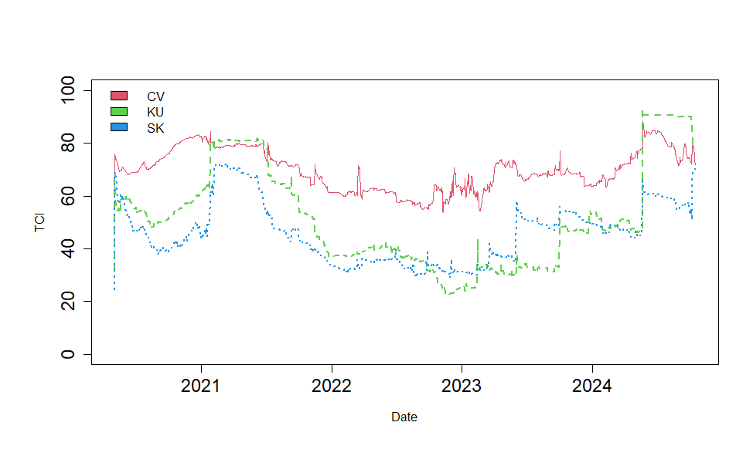
Figure 1: Total time-varying Return connectedness between green assets (VOLATILITY (CV), KURTOSIS (KU) and SKEWNESS (SK)).
Notes: System-wide total dynamic connectedness index is based on a 1st-order TVP-VAR with a 1st-order delay length and a 28-level GFEVD.
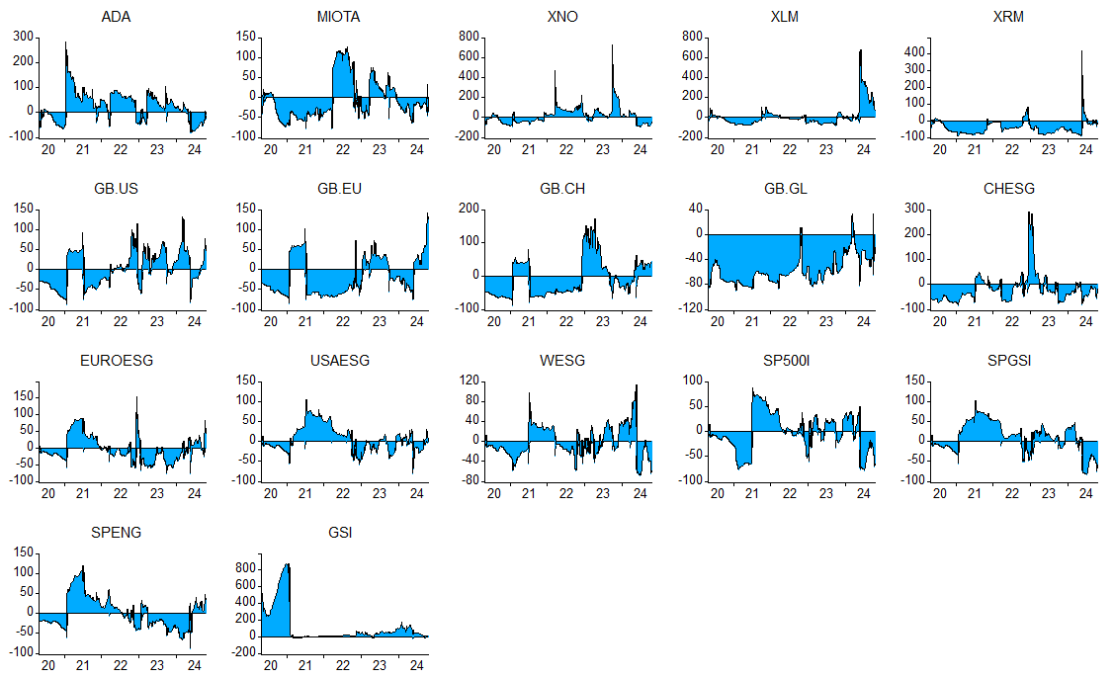
Figure 2: Net total spillovers (VOLATILITY). Notes: See Figure 1
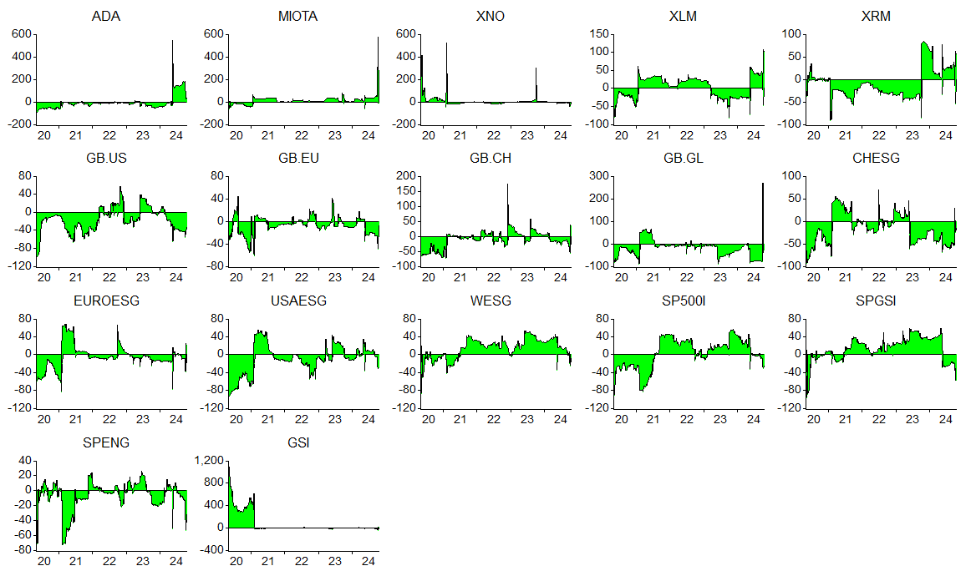
Figure 3: Net total spillovers (SKEWNESS).
Notes: See Figure 1.

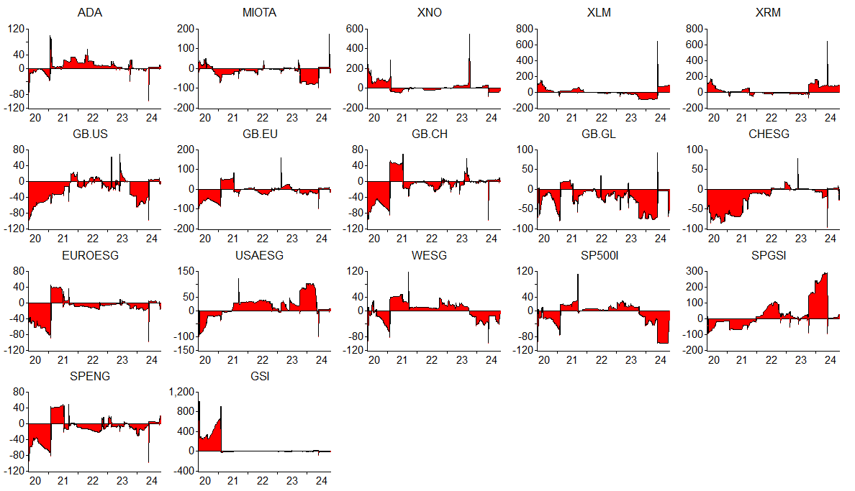
Figure 4: Net total spillovers (KURTOSIS). Notes: See Figure 1.

- Network Connectedness (VOLATILITY) | - Network Connectedness (SKEWNESS) | - Network Connectedness (KURTOSIS)
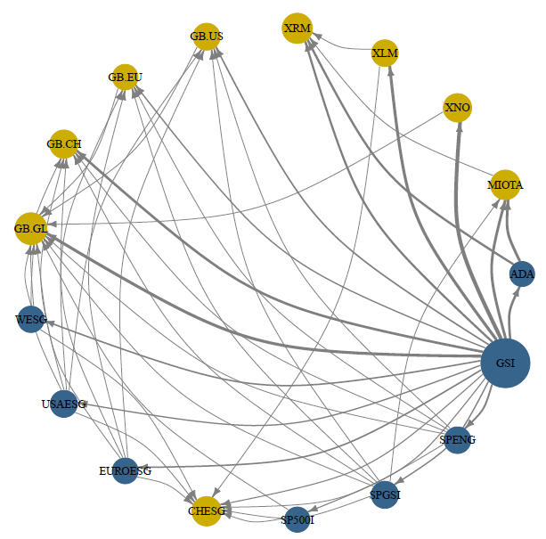
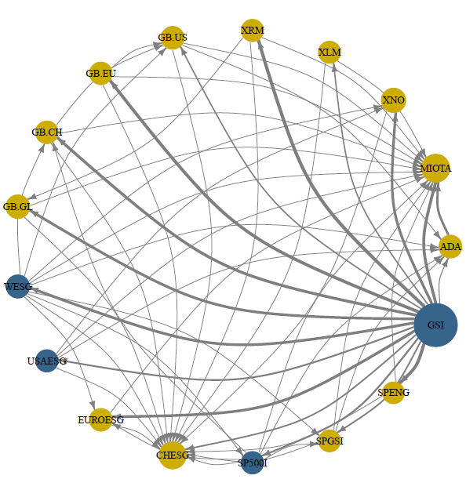
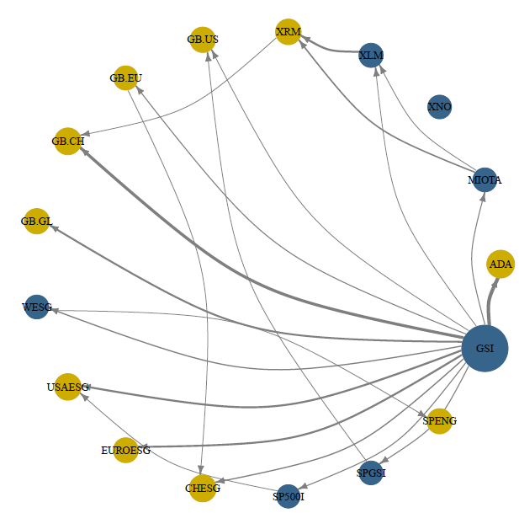
Figure 5: Network Connectedness between green assets during COVID-19. System-wide total dynamic connectedness index is based on a 1st-order TVP-VAR with a 1st-order delay length and a 28-level GFEVD.

Notes: This network graph illustrates the degree of total connectedness in a system that consists of Islamic banks and green bond returns over the full sample period. The size of the node shows the magnitude of contribution of each variable to system connectedness, while the color indicates the origin of connectedness. Node size signifies the extent of spillovers effect and color specifies whether a market is a net transmitter (green) or recipient (pink) of spillovers. The forced directed layout algorithm set node location where the sum of the vectors set the node route. Arrow width signifies the strength of the pairwise spillovers and color specifies strongest (red) to weakest (black) directions of spillovers.

- Network Connectedness (VOLATILITY) | - Network Connectedness (SKEWNESS) | - Network Connectedness (KURTOSIS)
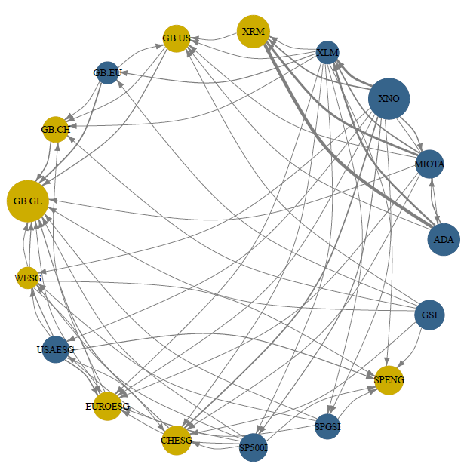
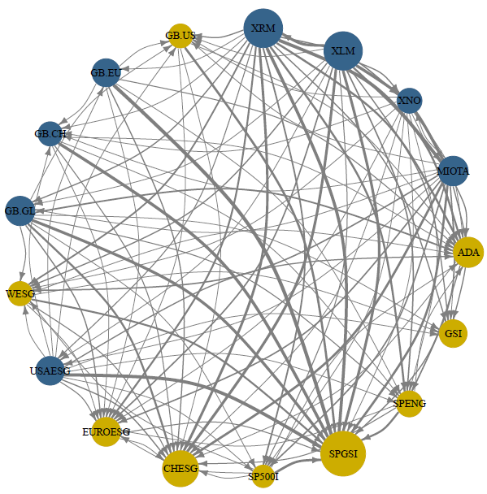
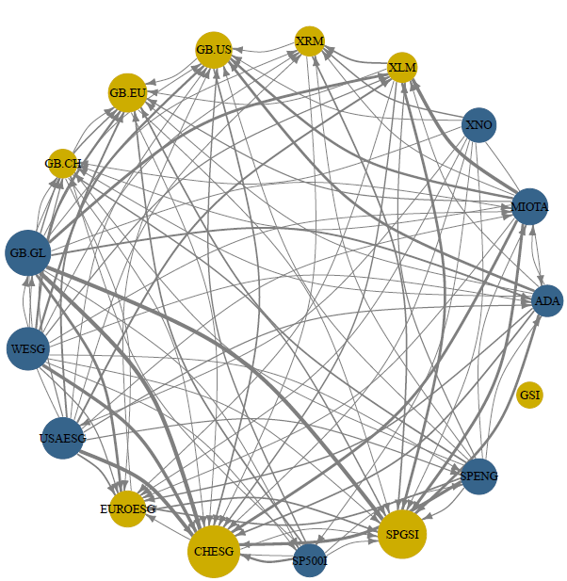
Figure 6: Network Connectedness between green assets during Russia-Ukraine war. System-wide total dynamic connectedness index is based on a 1st-order TVP-VAR with a 1st-order delay length and a 28-level GFEVD.

Notes: See figure 5.

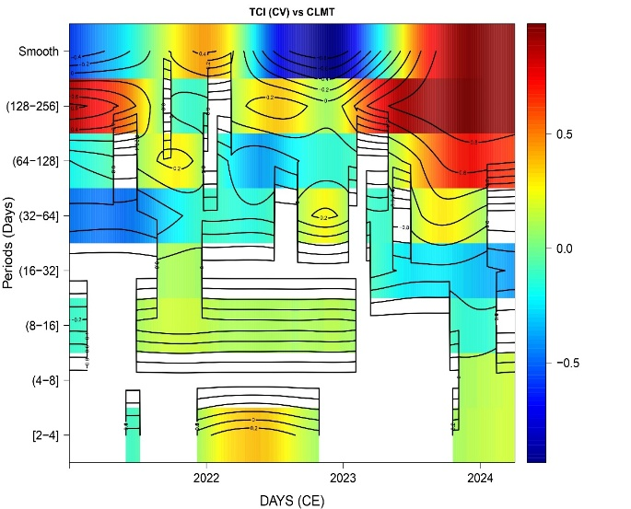
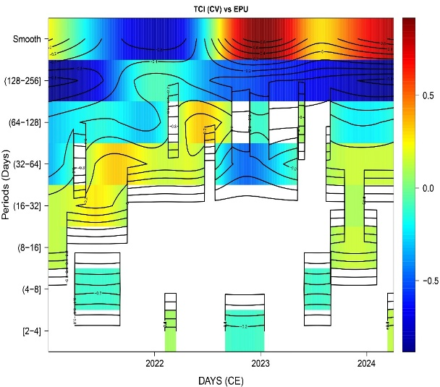
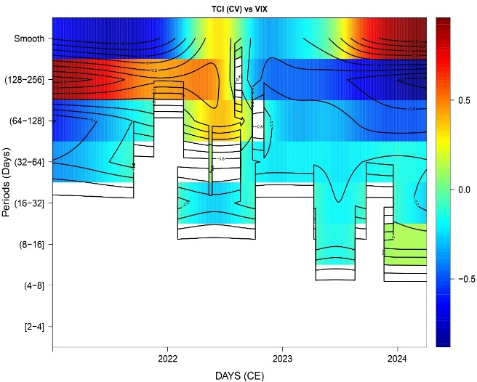
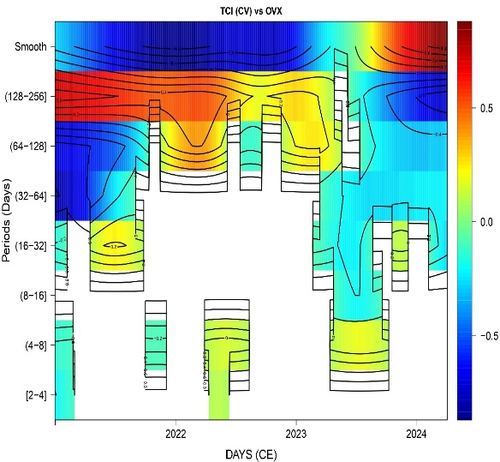
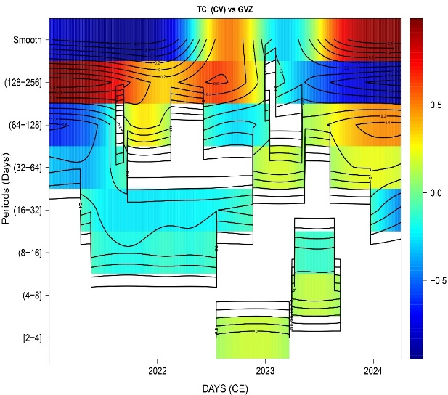
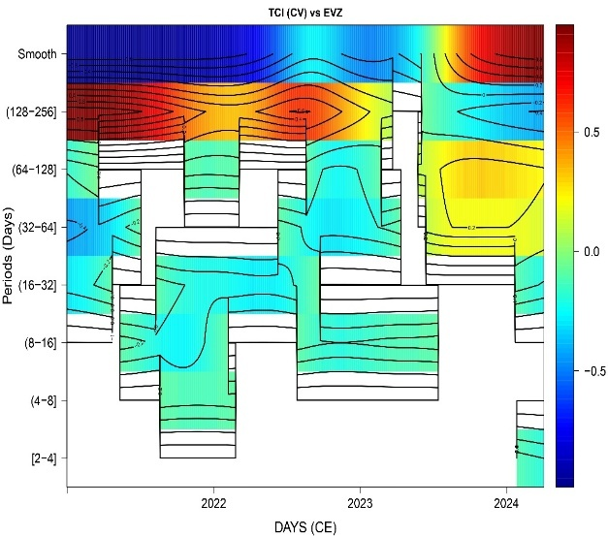
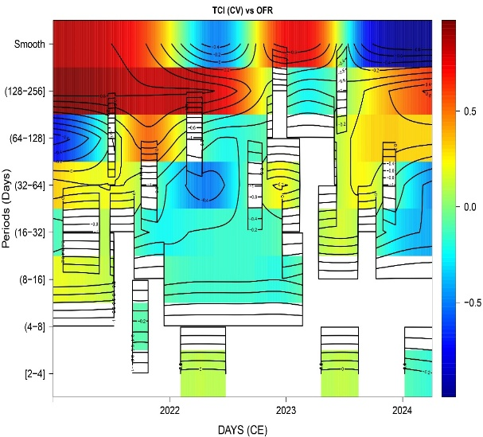
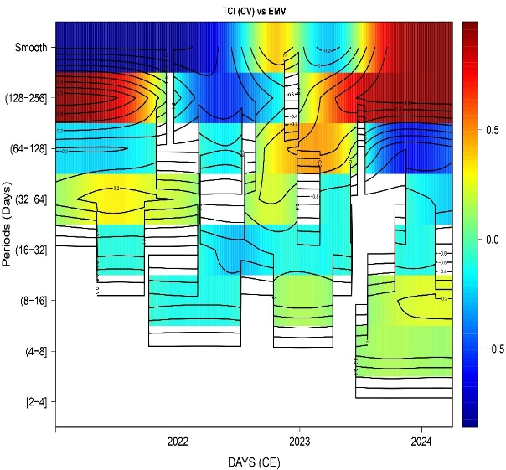
Figure 7: Wavelet local multiple correlation (bivariate case) for TCI (CV), CLMT, EPU, VIX, OVX, GVZ, EVZ, OFR, EMV. Blank space shows that points are insignificant (outside 95 % CI). WMCL parameters: window = Gaussian, M = 1627/5 = 325 (days), Wf = “la6”.

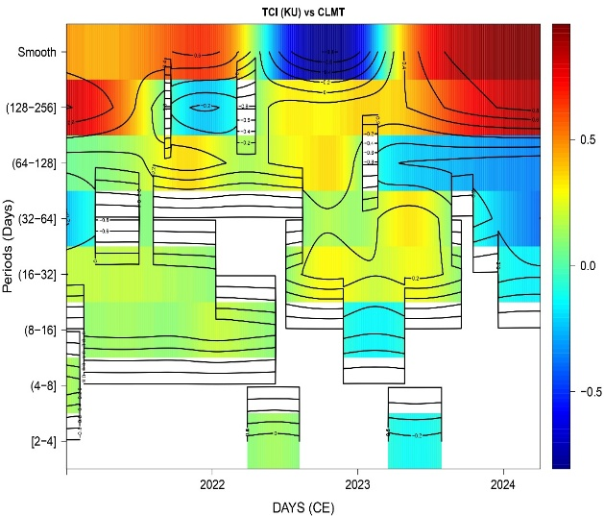
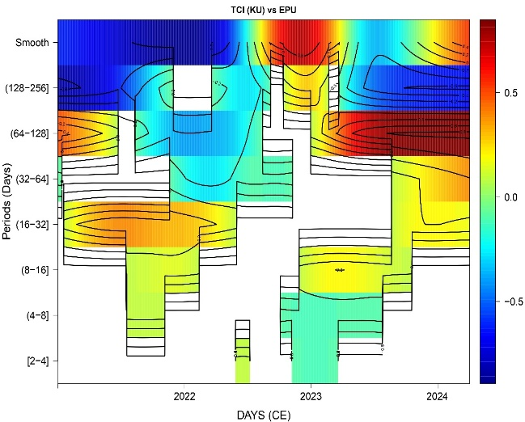
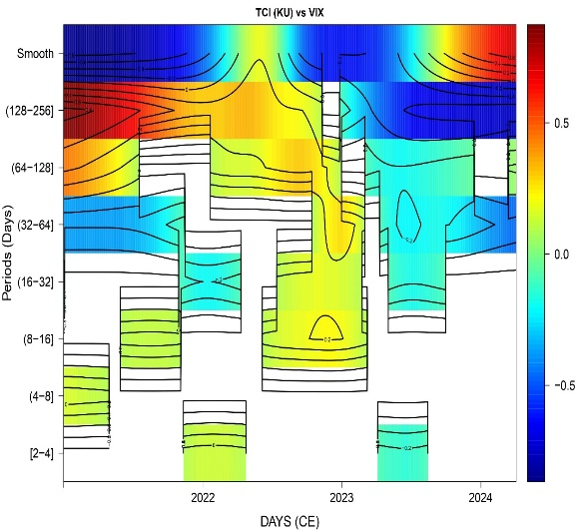
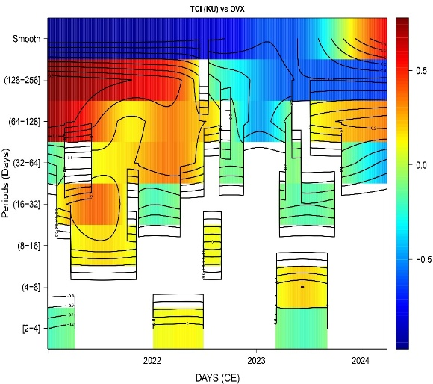
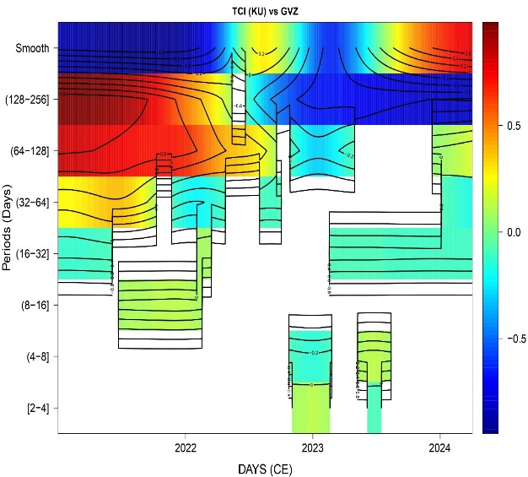
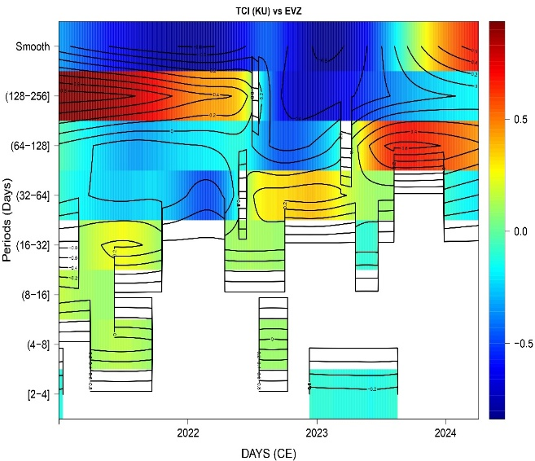
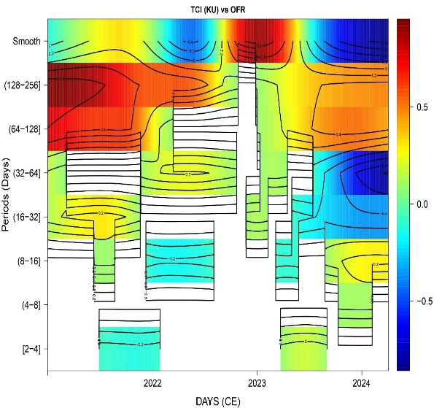
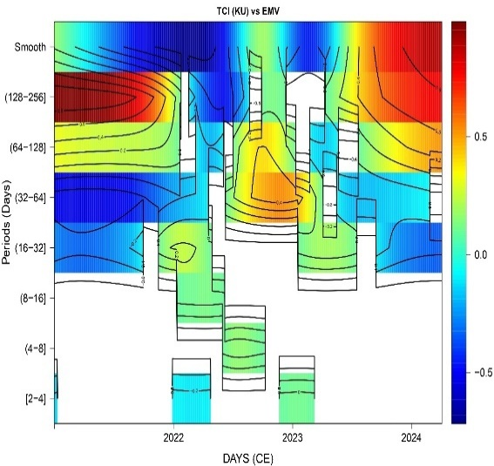
Figure 8: Wavelet local multiple correlation (bivariate case) for TCI (KU), CLMT, EPU, VIX, OVX, GVZ, EVZ, OFR, EMV. Blank space shows that points are insignificant (outside 95 % CI). WMCL parameters: window = Gaussian, M = 1627/5 = 325 (days), Wf = “la6”.

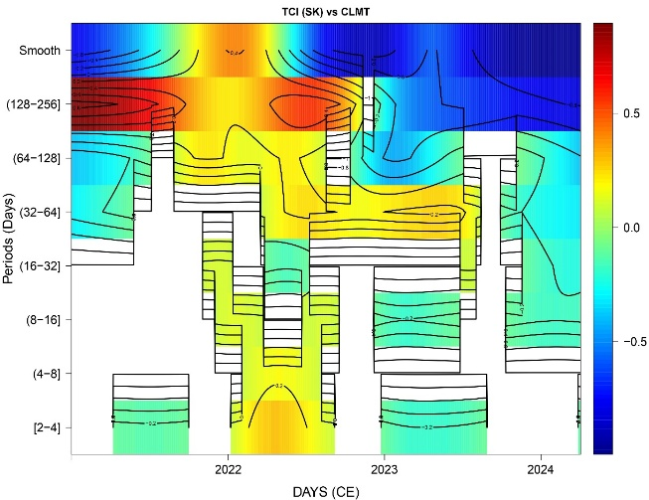
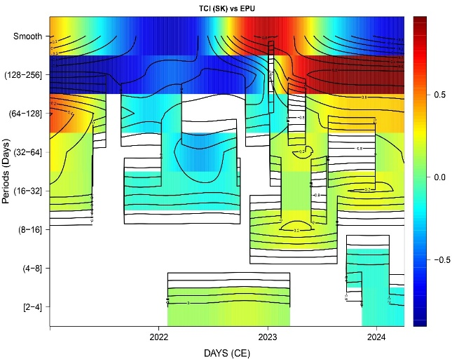
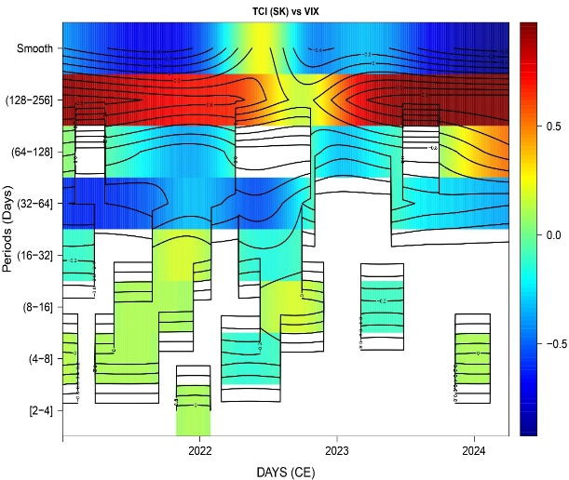
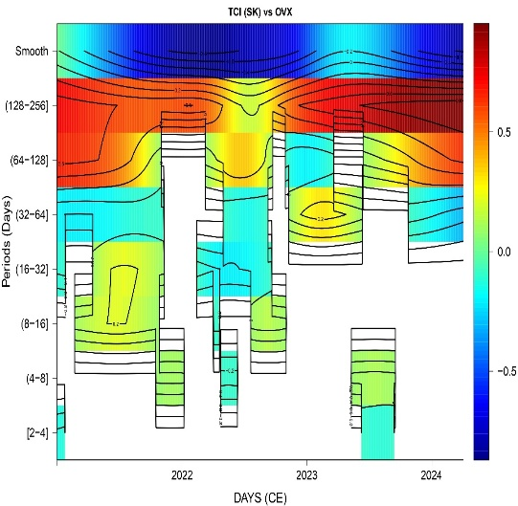
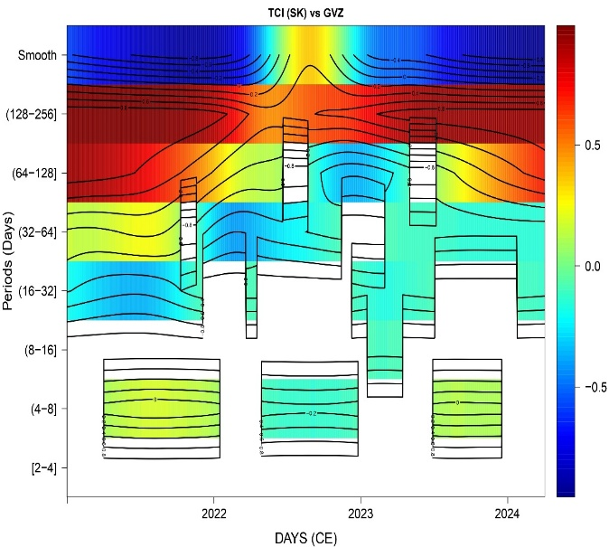
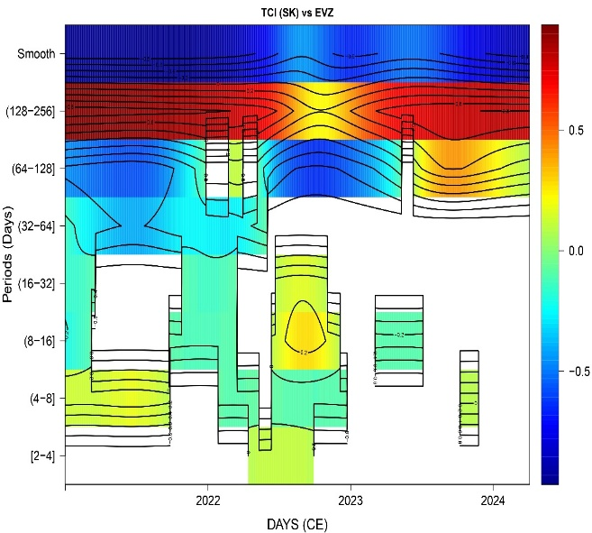
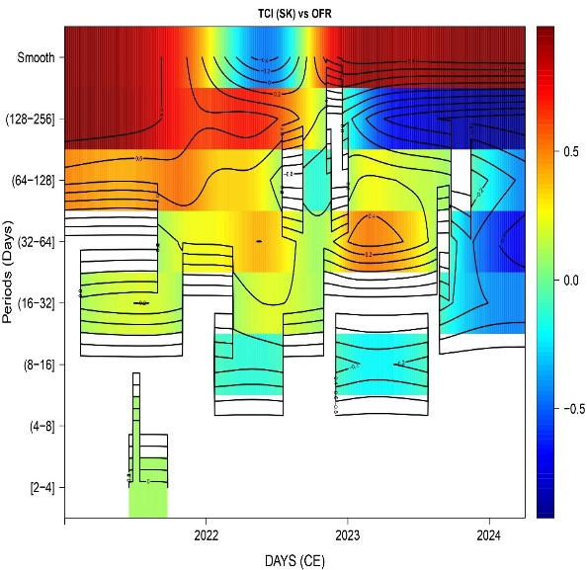
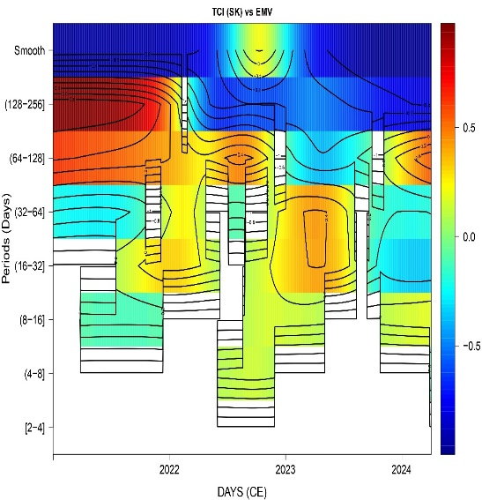
Figure 9: Wavelet local multiple correlation (bivariate case) for TCI (SK), CLMT, EPU, VIX, OVX, GVZ, EVZ, OFR, EMV. Blank space shows that points are insignificant (outside 95 % CI). WMCL parameters: window = Gaussian, M = 1627/5 = 325 (days), Wf = “la6”.

Table A.1. Variables to Determine the Spillovers
Variable | Description
EPU | EPU index shows the relevant consistency of own-country newspaper information in which consist of a threesome of conditions referring to the economy (E), policy (P) and uncertainty (U). Former investigations indicate an inverted connection among transformations in EPU and Green markets (Billah et al., 2023). Therefore, the negative sign will be expecting from EPU.
VIX | The VIX is a real-time market index that meets market assumptions for volatility over the next 30 days. Considering the bond attributes of Sukuk and green bonds, rises in the degree of the VIX possess an adverse effect on green markets, which decreases the TSI. As a result, we anticipate. an adverse indication for the VIX.
OVX | OVX is the expected 30-day crude oil volatility estimate since the US Oil Fund (USO) set the price. Rises in the degree of the OVX come with a negative effect on green bond prices (Saeed et al., 2021), which results in a decrease in the degree of the TSI. Therefore, the negative sign will be expecting from OVX.
GVZ | GVZ is an estimation regarding the anticipated 30-day volatility of returns on the SPDR Gold Shares ETF (GLD).
OFR | A daily overview of the stress levels in global financial markets is provided by the OFR Financial Stress Index (OFR FSI). The index is created using 33 financial market indicators, such as yield spreads, valuation measures, and interest rates. Stress levels above the average are indicated by a positive OFR FSI, while stress levels below the average are indicated by a negative OFR FSI.
EMV | Baker et al., (2019) developed an index which is called Equity Market Volatility (EMV) tracker, and it is being based on the eleven major U.S. newspapers. Moreover, this index closely moves with the VIX and with realized volatility on the S&P 500.
EVZ | The CBOE Euro Currency Volatility Index tracks the expected volatility of the EUR/USD exchange rate over 30 days. This is measured using the VIX methodology on the options of the Currency Shares Euro Trust (FXE).
CLMT | The MSCI World Climate Change Index (CLMT) is accorded to the MSCI World Index, it is relative index and consists of substantial and mid-cap securities across 23 Developed regions. The index aims to represent the efficiency of an investment strategy that re-weights securities based upon the opportunities and risks connected with the transition to a lower carbon economy, although looking for to reduce exemptions from the relative index.

Table A.2. Correlation Coefficients of Explanatory Variables
Explanatory variables | EPU | VIX | OVX | GVZ | GFS | EMV | EVZ | CLMT
EPU | 1.00
VIX | 0.17 | 1.00
OVX | 0.13 | 0.48 | 1.00
GVZ | 0.11 | 0.45 | 0.27 | 1.00
OFR | -0.18 | 0.05 | 0.31 | 0.13 | 1.00
EMV | 0.23 | -0.06 | 0.27 | -0.26 | -0.13 | 1.00
EVZ | 0.10 | 0.13 | -0.07 | 0.11 | -0.32 | 0.14 | 1.00
CLMT | 0.03 | 0.57 | 0.22 | 0.25 | 0.40 | -0.05 | -0.14 | 1.00

In this research, we examine the benchmark values for κ1 and κ2 as indicated by the study of Koop and Korobilis (2014), where κ1 is set at 0.99 and κ2 at 0.96. It should also be noted that while the computation methods are available, allowing for gradual fluctuations in the decay factors, we choose to keep them at fixed values. This approach aligns with the findings of Koop and Korobilis (2013), who also found that introducing time-varying decay factors in relation to forecasting performance was questionable and significantly increased the computational issues of the Kalman filter algorithm.

